Southey to Sassoon:

The development of the War Poem in the 19th and 20th centuries.

A resource for Year 9.

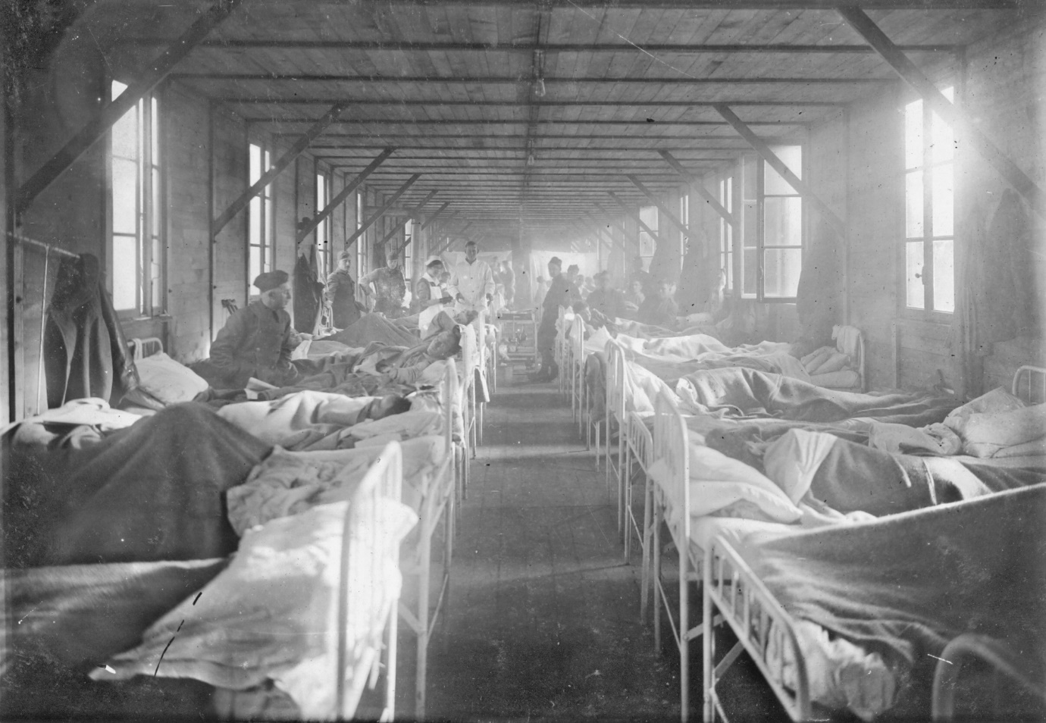

Name:………………………………………………………………………………………………………
Form: ……………………………………………………………………………………………………...

Robert Southey (1774-1843):
The Battle of Blenheim

Prep task: Research the Romantic Movement. Make 5 bullet points focused on the attitude of the Romantics to the individual and the state.

It was a summer evening,
Old Kaspar's work was done,
And he before his cottage door
Was sitting in the sun,
And by him sported on the green
His little grandchild Wilhelmine.

She saw her brother Peterkin
Roll something large and round,
Which he beside the rivulet
In playing there had found;
He came to ask what he had found,
That was so large, and smooth, and round.

Old Kaspar took it from the boy,
Who stood expectant by;
And then the old man shook his head,
And, with a natural sigh,
"'Tis some poor fellow's skull," said he,
"Who fell in the great victory.

"I find them in the garden,
For there's many here about;
And often when I go to plough,
The ploughshare turns them out!
For many thousand men," said he,
"Were slain in that great victory."

"Now tell us what 'twas all about,"
Young Peterkin, he cries;
And little Wilhelmine looks up
With wonder-waiting eyes;
"Now tell us all about the war,
And what they fought each other for."

"It was the English," Kaspar cried,
"Who put the French to rout;
But what they fought each other for,
I could not well make out;
But everybody said," quoth he,
"That 'twas a famous victory.

"My father lived at Blenheim then,
Yon little stream hard by;
They burnt his dwelling to the ground,
And he was forced to fly;
So with his wife and child he fled,
Nor had he where to rest his head.

"With fire and sword the country round
Was wasted far and wide,
And many a childing mother then,
And new-born baby died;
But things like that, you know, must be
At every famous victory.

"They say it was a shocking sight
After the field was won;
For many thousand bodies here
Lay rotting in the sun;
But things like that, you know, must be
After a famous victory.

"Great praise the Duke of Marlbro' won,
And our good Prince Eugene."
"Why, 'twas a very wicked thing!"
Said little Wilhelmine.
"Nay... nay... my little girl," quoth he,
"It was a famous victory.

"And everybody praised the Duke
Who this great fight did win."
"But what good came of it at last?"
Quoth little Peterkin.
"Why that I cannot tell," said he,
"But 'twas a famous victory."

Answer these questions in your books after the discussion of the poem.
1: What do you notice about the structure of this poem?
2: How many characters are there in this poem?
3: What sort of poem is this?
4: In what way do the younger character educate their grandfather?
5: What does this suggest about the attitude to war and to authority which developed into the Romantic Movement at the end of the 18th Century?
6: Do you see the irony in this poem?
7: This is not a highly figurative poem. How does Southey develop the poem to move the reader?

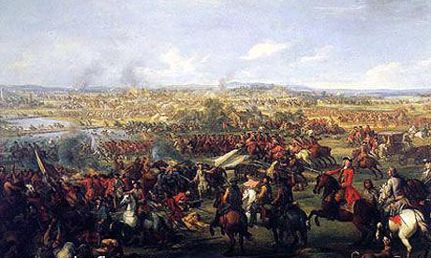

The Charge of the Light Brigade
BY ALFRED, LORD TENNYSON (1809-1892)
I
Half a league, half a league,
Half a league onward,
All in the valley of Death
Rode the six hundred.
“Forward, the Light Brigade!
Charge for the guns!” he said.
Into the valley of Death
Rode the six hundred.

II
“Forward, the Light Brigade!”
Was there a man dismayed?
Not though the soldier knew
Someone had blundered.
Theirs not to make reply,
Theirs not to reason why,
Theirs but to do and die.
Into the valley of Death
Rode the six hundred.

III
Cannon to right of them,
Cannon to left of them,
Cannon in front of them
Volleyed and thundered;
Stormed at with shot and shell,
Boldly they rode and well,
Into the jaws of Death,
Into the mouth of hell
Rode the six hundred.

IV
Flashed all their sabres bare,
Flashed as they turned in air
Sabring the gunners there,
Charging an army, while
All the world wondered.
Plunged in the battery-smoke
Right through the line they broke;
Cossack and Russian
Reeled from the sabre stroke
Shattered and sundered.
Then they rode back, but not
Not the six hundred.

V
Cannon to right of them,
Cannon to left of them,
Cannon behind them
Volleyed and thundered;
Stormed at with shot and shell,
While horse and hero fell.
They that had fought so well
Came through the jaws of Death,
Back from the mouth of hell,
All that was left of them,
Left of six hundred.

VI
When can their glory fade?
O the wild charge they made!
All the world wondered.
Honour the charge they made!
Honour the Light Brigade,
Noble six hundred!

Questions:
1: Research and note 5 facts about the Charge of the Light Brigade.
2: In stanza 1 Tennyson writes: ‘Charge for the guns!” he said.’ Who is ‘he’ and what does this suggest is becoming a suitable topic for the poet depicting war?

3: Find another example of Tennyson developing this line of criticism. Quote the line and explain how the language has an impact on the reader.

4: Read the poem aloud. How does Tennyson use rhythm in the outer stanzas?

5: How does the rhythm create a different effect tin stanzas 3 and 5?

6: There is powerful imagery in Stanza 3 – whence does Tennyson derive his imagery in this stanza and what effect tis created?

7: Write a paragraph to explain the message of this poem. Remember to quote in your response.

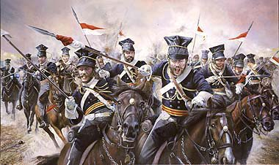

Come Up from the Fields Father: Walt Whitman (1819-1892)
Come up from the fields father, here’s a letter from our Pete,
And come to the front door mother, here’s a letter from thy dear son.

Lo, ’tis autumn,
Lo, where the trees, deeper green, yellower and redder,
Cool and sweeten Ohio’s villages with leaves fluttering in the moderate wind,
Where apples ripe in the orchards hang and grapes on the trellis’d vines,
(Smell you the smell of the grapes on the vines?
Smell you the buckwheat where the bees were lately buzzing?)

Above all, lo, the sky so calm, so transparent after the rain, and with wondrous clouds,
Below too, all calm, all vital and beautiful, and the farm prospers well.

Down in the fields all prospers well,
But now from the fields come father, come at the daughter’s call,
And come to the entry mother, to the front door come right away.

Fast as she can she hurries, something ominous, her steps trembling,
She does not tarry to smooth her hair nor adjust her cap.

Open the envelope quickly,
O this is not our son’s writing, yet his name is sign’d,
O a strange hand writes for our dear son, O stricken mother’s soul!
All swims before her eyes, flashes with black, she catches the main words only,
Sentences broken, gunshot wound in the breast, cavalry skirmish, taken to hospital,
At present low, but will soon be better.

Ah now the single figure to me,
Amid all teeming and wealthy Ohio with all its cities and farms,
Sickly white in the face and dull in the head, very faint,
By the jamb of a door leans.

Grieve not so, dear mother, (the just-grown daughter speaks through her sobs,
The little sisters huddle around speechless and dismay’d,)
See, dearest mother, the letter says Pete will soon be better.
Alas poor boy, he will never be better, (nor may-be needs to be better, that brave and simple soul,)
While they stand at home at the door he is dead already,
The only son is dead.

But the mother needs to be better,
She with thin form presently drest in black,
By day her meals untouch’d, then at night fitfully sleeping, often waking,
In the midnight waking, weeping, longing with one deep longing,
O that she might withdraw unnoticed, silent from life escape and withdraw,
To follow, to seek, to be with her dear dead son.
Questions:
1: What has changed in terms of the structure of this poem and the previous two?
2: This form of verse allows the writer to present key ideas without worrying about rhyme or regular rhythm. Choose three examples of the poet using specific language to create effect in this poem. What does he say, how does he say it and what is the effect he creates?
3: How many voices do we hear in this poem?
4: There is a new focus in this poem – it is still about war, but what is the focus of the poem?
5: Given the nature of a civil war, why is the central theme of this poem so appropriate?
6: How does the depiction of nature create a contrast with the main events described?
7: Read the final stanza. How does the punctuation chosen by Whitman add great power to the image of the grieving mother?
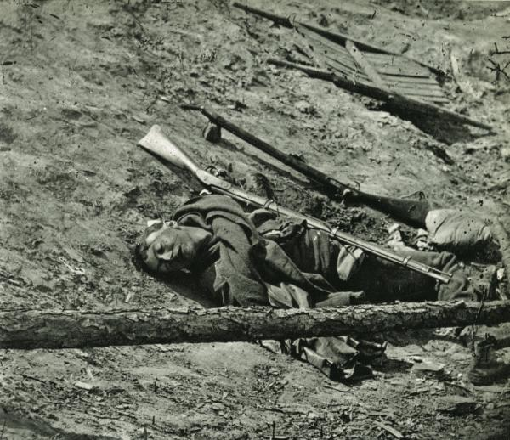

Danny Deever
BY RUDYARD KIPLING
‘What are the bugles blowin’ for?' said Files-on-Parade.
‘To turn you out, to turn you out,’ the Colour-Sergeant said.
‘What makes you look so white, so white?’ said Files-on-Parade.
‘I’m dreadin’ what I’ve got to watch,’ the Colour-Sergeant said.
For they’re hangin’ Danny Deever, you can hear the Dead March play,
The Regiment’s in ’ollow square—they’re hangin’ him to-day;
They’ve taken of his buttons off an’ cut his stripes away,
An’ they're hangin’ Danny Deever in the mornin’.

‘What makes the rear-rank breathe so ’ard?’ said Files-on-Parade.
‘It’s bitter cold, it's bitter cold,’ the Colour-Sergeant said.
‘What makes that front-rank man fall down?’ said Files-on-Parade.
‘A touch o’ sun, a touch o’ sun,’ the Colour-Sergeant said.
They are hangin’ Danny Deever, they are marchin’ of ’im round,
They ’ave ’alted Danny Deever by ’is coffin on the ground;
An’ ’e’ll swing in ’arf a minute for a sneakin’ shootin’ hound—
O they’re hangin’ Danny Deever in the mornin!’

‘’Is cot was right-’and cot to mine,’ said Files-on-Parade.
‘’E’s sleepin’ out an’ far to-night,’ the Colour-Sergeant said.
‘I’ve drunk ’is beer a score o’ times,’ said Files-on-Parade.
‘’E’s drinkin’ bitter beer alone,’ the Colour-Sergeant said.
They are hangin’ Danny Deever, you must mark ’im to ’is place,
For ’e shot a comrade sleepin’—you must look ’im in the face;
Nine ’undred of ’is county an’ the Regiment’s disgrace,
While they’re hangin’ Danny Deever in the mornin’.

‘What’s that so black agin the sun?’ said Files-on-Parade.
‘It’s Danny fightin’ ’ard for life,’ the Colour-Sergeant said.
‘What’s that that whimpers over’ead?’ said Files-on-Parade.
‘It’s Danny’s soul that’s passin’ now,’ the Colour-Sergeant said.
For they’re done with Danny Deever, you can ’ear the quickstep play,
The Regiment’s in column, an’ they’re marchin’ us away;
Ho! the young recruits are shakin’, an’ they’ll want their beer to-day,
After hangin’ Danny Deever in the mornin’!
Read the poem and consider the subject matter. The central theme is cowardice and the response of the army to this behaviour.
Create an art work to present the poem to the class – you can be as abstract as you wish. You should ensure that you annotate the work or provide a handout explaining your thought processes.

The Man He Killed
BY THOMAS HARDY (1840-1928)
"Had he and I but met
By some old ancient inn,
We should have sat us down to wet
Right many a nipperkin!

"But ranged as infantry,
And staring face to face,
I shot at him as he at me,
And killed him in his place.

"I shot him dead because —
Because he was my foe,
Just so: my foe of course he was;
That's clear enough; although

"He thought he'd 'list, perhaps,
Off-hand like — just as I —
Was out of work — had sold his traps —
No other reason why.

"Yes; quaint and curious war is!
You shoot a fellow down
You'd treat if met where any bar is,
Or help to half-a-crown."

Question: How does Hardy use punctuation to create the sense of mental trauma being suffered in this poem?

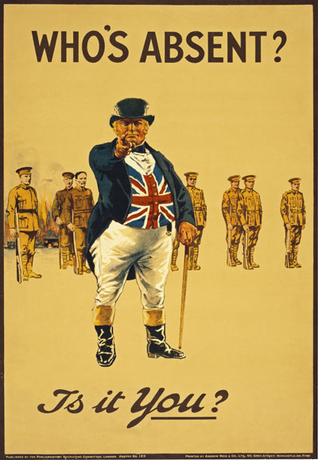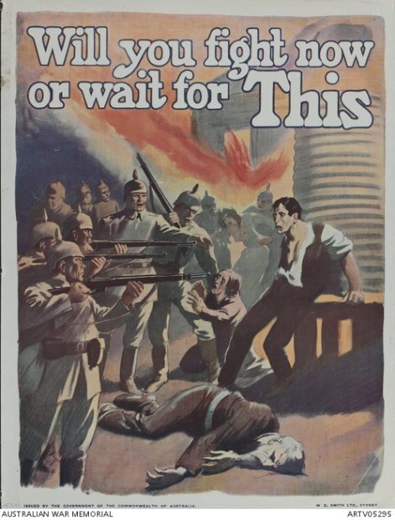

Autumn 1914 Thomas Hardy

'O England, may God punish thee!'
— Is it that Teuton genius flowers
Only to breathe malignity
Upon its friend of earlier hours?
— We have eaten your bread, you have eaten ours,
We have loved your burgs, your pines' green moan,
Fair Rhine-stream, and its storied towers;
Your shining souls of deathless dowers
Have won us as they were our own:

We have nursed no dreams to shed your blood,
We have matched your might not rancorously
Save a flushed few whose blatant mood
You heard and marked as well as we
To tongue not in their country's key;
But yet you cry with face aflame,
'O England, may God punish thee!'
And foul in onward history,
And present sight, your ancient name.
Question: Look at the two recruiting posters. How does their message compare to that of Hardy in this poem? What new idea might be entering the genre at this time?

Vitaï Lampada - Poem by Sir Henry Newbolt (1862-1938)
There's a breathless hush in the Close to-night—
Ten to make and the match to win—
A bumping pitch and a blinding light,
An hour to play and the last man in.
And it's not for the sake of a ribboned coat,
Or the selfish hope of a season's fame,
But his captain's hand on his shoulder smote
'Play up! play up! and play the game! '
The sand of the desert is sodden red,—
Red with the wreck of a square that broke; —
The Gatling's jammed and the Colonel dead,
And the regiment blind with dust and smoke.
The river of death has brimmed his banks,
And England's far, and Honour a name,
But the voice of a schoolboy rallies the ranks:
'Play up! play up! and play the game! '
This is the word that year by year,
While in her place the school is set,
Every one of her sons must hear,
And none that hears it dare forget.
This they all with a joyful mind
Bear through life like a torch in flame,
And falling fling to the host behind—
'Play up! play up! and play the game!
Question: This poem presents a common ‘conceit’ of patriotic war poetry. War as a Great Game played by boys from wealthy public schools – all likely to be officer class.
The poem is designed to raise the spirits of the young soldiers and to inspire a vision of heroism. Do you find it successful? Explain your response.
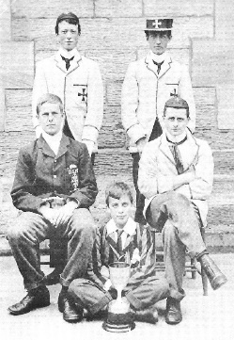

Disabled
BY WILFRED OWEN (1893-1918)
He sat in a wheeled chair, waiting for dark,
And shivered in his ghastly suit of grey,
Legless, sewn short at elbow. Through the park
Voices of boys rang saddening like a hymn,
Voices of play and pleasure after day,
Till gathering sleep had mothered them from him.

* * * * *

About this time Town used to swing so gay
When glow-lamps budded in the light-blue trees,
And girls glanced lovelier as the air grew dim,—
In the old times, before he threw away his knees.
Now he will never feel again how slim
Girls' waists are, or how warm their subtle hands,
All of them touch him like some queer disease.

* * * * *

There was an artist silly for his face,
For it was younger than his youth, last year.
Now, he is old; his back will never brace;
He's lost his colour very far from here,
Poured it down shell-holes till the veins ran dry,
And half his lifetime lapsed in the hot race
And leap of purple spurted from his thigh.

* * * * *

One time he liked a blood-smear down his leg,
After the matches carried shoulder-high.
It was after football, when he'd drunk a peg,
He thought he'd better join. He wonders why.
Someone had said he'd look a god in kilts.
That's why; and maybe, too, to please his Meg,
Aye, that was it, to please the giddy jilts,
He asked to join. He didn't have to beg;
Smiling they wrote his lie: aged nineteen years.
Germans he scarcely thought of, all their guilt,
And Austria's, did not move him. And no fears
Of Fear came yet. He thought of jewelled hilts
For daggers in plaid socks; of smart salutes;
And care of arms; and leave; and pay arrears;
Esprit de corps; and hints for young recruits.
And soon, he was drafted out with drums and cheers.

* * * * *

Some cheered him home, but not as crowds cheer Goal.
Only a solemn man who brought him fruits
Thanked him; and then inquired about his soul.

* * * * *

Now, he will spend a few sick years in institutes,
And do what things the rules consider wise,
And take whatever pity they may dole.
Tonight he noticed how the women's eyes
Passed from him to the strong men that were whole.
How cold and late it is! Why don't they come
And put him into bed? Why don't they come?

Questions
1: Look at Owen’s dates. Why do you think we may view him as an authentic voice of the first world war?
2: How does Owen use the contrast of time in this poem?
3: Find 3 examples of colour imagery in this poem and explore their effectiveness.
4: Why does Owen decide to repeat the phrase in the last two lines?
5: What imager links this poem with Vitai Lampada? Do you think Newbolt and Owen share the same view of war? Explain your view.
6: “How senseless is everything that can ever be written, done, or thought, when such things are possible. It must be all lies and of no account when the culture of a thousand years could not prevent this stream of blood being poured out, these torture-chambers in their hundreds of thousands. A hospital alone shows what war is.”
― Erich Maria Remarque, All Quiet on the Western Front

How does this sentiment form a great novel about the war link to the poem we have been reading? We will be discussing this in class. Use any resources and all the poems read so far to prepare points for the discussion.

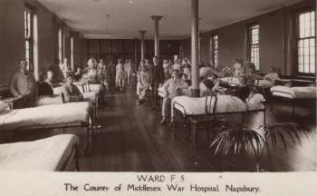

Glory of Women
BY SIEGFRIED SASSOON (1886-1967)
You love us when we're heroes, home on leave,
Or wounded in a mentionable place.
You worship decorations; you believe
That chivalry redeems the war's disgrace.
You make us shells. You listen with delight,
By tales of dirt and danger fondly thrilled.
You crown our distant ardours while we fight,
And mourn our laurelled memories when we're killed.
You can't believe that British troops “retire”
When hell's last horror breaks them, and they run,
Trampling the terrible corpses—blind with blood.
O German mother dreaming by the fire,
While you are knitting socks to send your son
His face is trodden deeper in the mud.

Futility
BY WILFRED OWEN
Move him into the sun—
Gently its touch awoke him once,
At home, whispering of fields half-sown.
Always it woke him, even in France,
Until this morning and this snow.
If anything might rouse him now
The kind old sun will know.

Think how it wakes the seeds—
Woke once the clays of a cold star.
Are limbs, so dear-achieved, are sides
Full-nerved, still warm, too hard to stir?
Was it for this the clay grew tall?
—O what made fatuous sunbeams toil
To break earth's sleep at all?

Essay Question: Consider these two Sonnets. Which do you find the more effective? Why?

