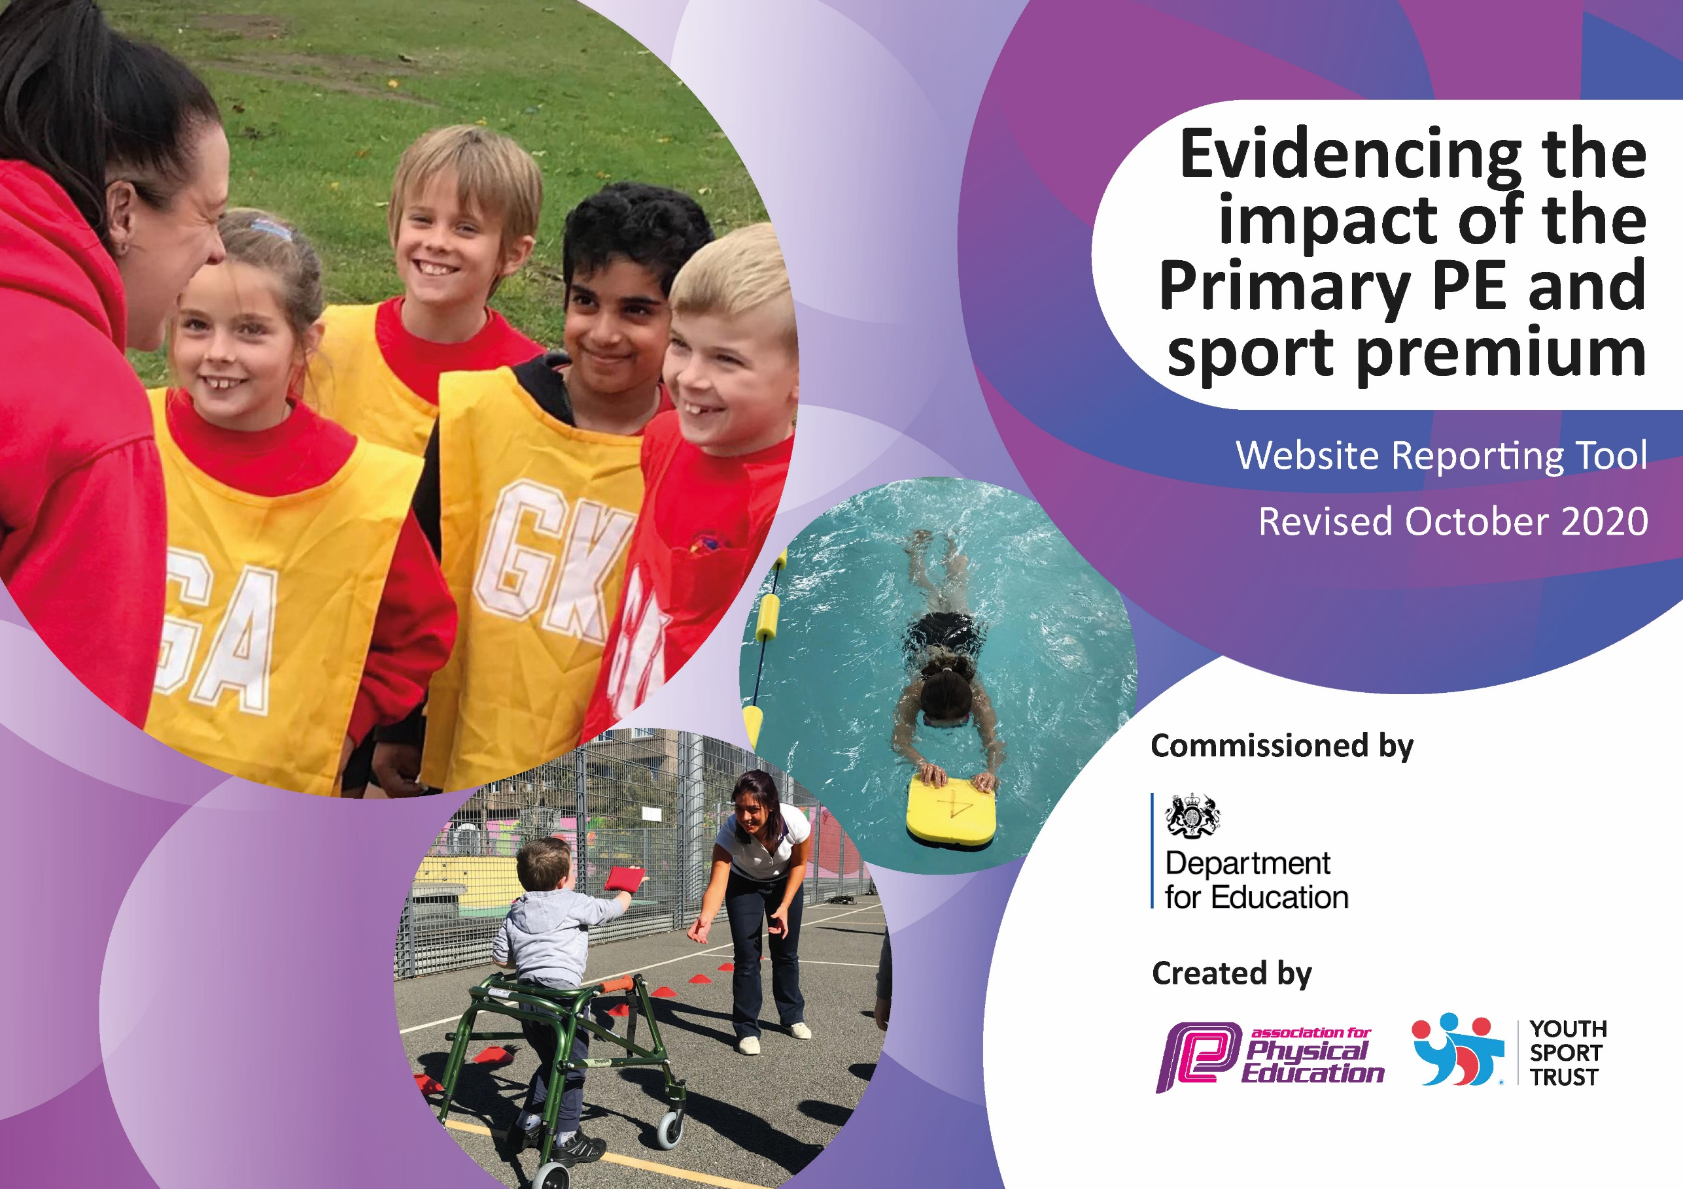
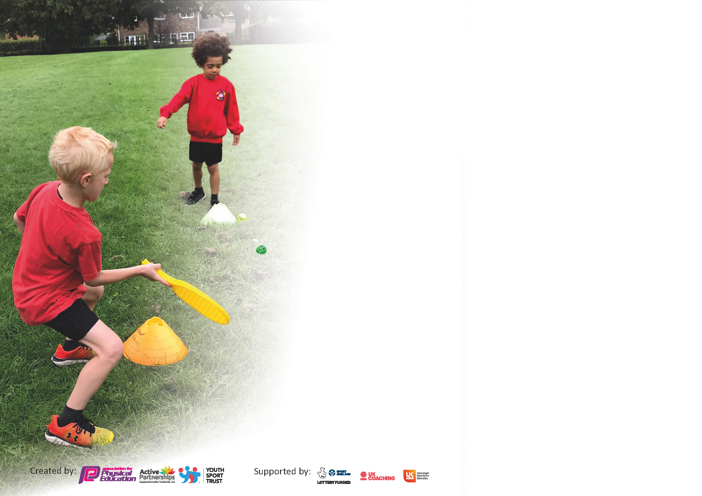

It is important that your grant is used effectively and based on school need. The Education Inspection Framework (Ofsted 2019 p64) makes clear there will be a focus on ‘whether leaders and those responsible for governors all understand their respective roles and perform these in a way that enhances the effectiveness of the school’.

Under the Quality of Education criteria (p41) inspectors consider the extent to which schools can articulate their curriculum (INTENT), construct their curriculum (IMPLEMENTATION) and demonstrate the outcomes which result (IMPACT).

To assist schools with common transferable language this template has been developed to utilise the same three headings which should make your plans easily transferable between working documents.

Schools must use the funding to make additional and sustainable improvements to the quality of Physical Education, School Sport and Physical Activity (PESSPA) they offer. This means that you should use
the Primary PE and sport premium to:

- Develop or add to the PESSPA activities that your school already offer
- Build capacity and capability within the school to ensure that improvements made now will benefit pupils joining the school in future years

Please visit gov.uk for the revised DfE guidance including the 5 key indicators across which schools should demonstrate an improvement. This document will help you to review your
provision and to report your spend. DfE encourages schools to use this template as an effective way of meeting the reporting requirements of the Primary PE and sport premium.

We recommend you start by reflecting on the impact of current provision and reviewing the previous spend.

Schools are required to publish details of how they spend this funding as well as on the impact it has on pupils’ PE and sport participation and attainment by the end of the summer term or by 31st July 2021 at the latest.

** In the case of any under-spend from 2019/20 which has been carried over this must be used and published by 31st March 2021.

We recommend regularly updating the table and publishing it on your website throughout the year. This evidences your ongoing self-evaluation of how you are using the funding to secure maximum, sustainable impact. Final copy must
be posted on your website by the end of the academic year and no later than the 31st July 2021. To see an example of how to complete the table please click HERE.
Created by: Supported by:

Please note: Although there has been considerable disruption in 2020 it is important that you publish details on your website of how you spend the funding - this is a legal requirement.
Support for review and reflection - considering the 5 key indicators from DfE, what development needs are a priority for your setting and your pupils now and why? Use the space below to reflect on previous spend and key achievements and areas for development.

N.B. In this section you should refer to any adjustments you might have made due to Covid-19 and how these will influence further improvement.
Key achievements to date until July 2020: | Areas for further improvement and baseline evidence of need:
- Continued participation in the School Games competitions.  - KS2 Football team continued to embed into the culture of the school.  - Get Set 4 PE scheme of work purchased to aid the teaching of high quality physical education during curriculum time.  - Both KS1 and KS2 have a sport specific approach to the PE curriculum.  - Sports Captains pupil leadership has been re-established and relaunched. | Continue to participate in a wide variety of school games competitions  Raise the attainment of children in KS2 swimming.  Further develop playtime activities to ensure 30 mins of physical activity for each child per day.

Did you carry forward an underspend from 2019-20 academic year into the current academic year? YES/NO * Delete as applicable

If YES you must complete the following section
If NO, the following section is not applicable to you

If any funding from the academic year 2019/20 has been carried over you MUST complete the following section. Any carried over funding MUST be spent by 31 March 2021.
Academic Year: September 2020 to March 2021 | Total fund carried over: £3350 | Date Updated:
What Key indicator(s) are you going to focus on? |  |  |  | Total Carry Over Funding:
 |  |  |  | £3350
Intent | Implementation |  | Impact
Your school focus should be clear how you want to impact on your pupils.  Improve the school’s physical environment to better support outdoor learning and the promotion of physical activity. | Make sure your actions to achieve are linked to your intentions:  Designated member of staff trained to lead on forest school and provide weekly sessions for all children.  Purchased required resources to support Forest School teaching. | Carry over funding allocated: £3350  £790  £1672.54 | Evidence of impact: How can you measure the impact on your pupils; you may have focussed on the difference that PE, SS & PA have made to pupils re-engagement with school. What has changed?:  Confidence: children will have the freedom, time and space to learn and demonstrate independence  Social skills: children gain increase awareness of the consequences of their actions on peers through team activities such as sharing tools and participating in play  Communication: language development will be prompted by the children’s sensory experiences  Motivation: the woodland will fascinate the children and develop a keenness to participate and the ability to concentrate over longer periods of time  Physical skills: develop physical stamina and gross and fine motor skills  Knowledge and understanding: the children will develop an interest in the natural surroundings and respect for the environment | Sustainability and suggested next steps and how does this link with the key indicators on which you are focussing this academic year?:  The new staff lead has written and implemented a Forest school scheme of work to encompass the whole school.  All children have attended weekly Forest school sessions that have impacted on physical and mental health well being.
Emotional support to build self-esteem and confidence to have a go and play with peers in school.  (Due to missing school due to Covid 19 we found certain pupils struggled with their confidence to play with others) | Employ specialist mentor to run sessions with individual children and pairs to raise self-esteem and confidence to play at playtimes with others and raise confidence. | £900 | Increased confidence in individual pupils to free play and take part in games/sports (individual or team). | Pupils achieve identified SEMH targets and show increased levels of independence, resilience, and a positive attitude to all areas of learning.

Meeting national curriculum requirements for swimming and water safety.

N.B Complete this section to your best ability. For example you might have practised safe self-rescue techniques on dry land.
What percentage of your current Year 6 cohort swim competently, confidently and proficiently over a distance of at least 25 metres?  N.B. Even though your pupils may swim in another year please report on their attainment on leaving primary school at the end of the summer term 2020. | 98% of children can swim 25 metres
What percentage of your current Year 6 cohort use a range of strokes effectively [for example, front crawl, backstroke and breaststroke]? | 98%
What percentage of your current Year 6 cohort perform safe self-rescue in different water-based situations? | 100%
Schools can choose to use the Primary PE and sport premium to provide additional provision for swimming but this must be for activity over and above the national curriculum requirements. Have you used it in this way? | No

Action Plan and Budget Tracking
Capture your intended annual spend against the 5 key indicators. Clarify the success criteria and evidence of impact that you intend to measure to evaluate for pupils today and for the future.

Academic Year: 2020/21 | Total fund allocated: £5000 | Date Updated:17th July 2021
Key indicator 1: The engagement of all pupils in regular physical activity – Chief Medical Officers guidelines recommend that primary school pupils undertake at least 30 minutes of physical activity a day in school |  |  |  | Percentage of total allocation:
 |  |  |  | %
Intent | Implementation |  | Impact | 70
Your school focus should be clear what you want the pupils to know and be able to do and about  what they need to learn and to  consolidate through practice: | Make sure your actions to achieve are linked to your intentions: | Funding allocated: | Evidence of impact: what do pupils now know and what can they now do? What has changed?: | Sustainability and suggested next steps:
Active travel through OPAL | - OPAL Training for staff  - OPAL lead  - Equipment | £3,500 | Since using OPAL the behaviour levels during playtime have dropped and we have seen children working together as a team to build structures.  The full impact of OPAL hasn’t been shown yet due to COVID but it will be continuing onto this year. | The equipment will remain available to the students.
Key indicator 2: The profile of PESSPA being raised across the school as a tool for whole school improvement |  |  |  | Percentage of total allocation:
 |  |  |  | %
Intent | Implementation |  | Impact | 0
Your school focus should be clear what you want the pupils to know and be able to do and about  what they need to learn and to  consolidate through practice: | Make sure your actions to achieve are linked to your intentions: | Funding allocated: | Evidence of impact: what do pupils now know and what can they now do? What has changed?: | Sustainability and suggested next steps:
KS1 P.E Hub lesson planning scheme | Give teachers confidence to lead regular PE sessions. | £0 | To improve the confidence and therefore quantity of teacher led sessions during and throughout the year. Average hours exercise per week (sports coaching AND teacher taught sessions) based on last year’s data collection:  • Y3 access 2.5+  • Y4 access 2.5+  • Y5 access 3+  • Y6 access 3+  Increased use of gym apparatus 100% chn’ reaching national average amount of exercise per week. | Continued auditing of pupil engagement and attainment. Continued support for teaching staff and coaching staff. Continued provision of high quality coaching: Netball, Cricket, gymnastics, hockey. 20+ chn’ accessing weekly high level lessons. Raising participation of Bromley Primary Schools competitions.

Key indicator 3: Increased confidence, knowledge and skills of all staff in teaching PE and sport |  |  |  | Percentage of total allocation:
 |  |  |  | %
Intent | Implementation |  | Impact | 20
Your school focus should be clear | Make sure your actions to | Funding | Evidence of impact: what do | Sustainability and suggested
what you want the pupils to know | achieve are linked to your | allocated: | pupils now know and what | next steps:
and be able to do and about | intentions: |  | can they now do?  What has
what they need to learn and to |  |  | changed?:
consolidate through practice:
PE Lead release time | Cover costs to release teacher in order to implement action plan. | £1000 | PE lead has been tasked with the implementation of many of the responsibilities highlighted within this document.  - Planning and implementation of ‘Month of Sport’  - Planning and implementation of all extra-curricular clubs on offer throughout the year.  - Adaptation of the PE long term plan. - Ensuring participation in competitions both virtual and in-person  - Setting up and maintaining the rotation of playground activities and equipment. | To continue with the day-to-day running of PE and school sport throughout the year.  To act on feedback and make improvements to the offer of Physical Education at BTA Midfield.  To review the PE LTP to include indoor and outdoor activity to maximise the use of space in school. To review medium-term planning to ensure that planning and teaching matches the vision and intent of the Curriculum.
Key indicator 4: Broader experience of a range of sports and activities offered to all pupils |  |  |  | Percentage of total allocation:
 |  |  |  | %
Intent | Implementation |  | Impact | 0
Your school focus should be clear | Make sure your actions to | Funding | Evidence of impact: what do | Sustainability and suggested
what you want the pupils to know | achieve are linked to your | allocated: | pupils now know and what | next steps:
and be able to do and about | intentions: |  | can they now do?  What has
what they need to learn and to |  |  | changed?:
consolidate through practice:
Additional achievements:  To develop the provision of on-site orienteering and outdoor adventure to ensure a safe and sustainable addition to curriculum PE. | Create an all-weather orienteering trail, complete with equipment, resources and digital mapping and foundation phonics and number trail.  Orienteering equipment lent to us by Dartford orienteering club | £0 | OAA trail has been made within school and on the field. School has also been provided with a range of orienteering resources including Active Science, Active Phonics and age-appropriate team games.  Classes have used the orienteering maps and markers as a cross curricular link in Geography. | Children can access the orienteering equipment at all times throughout the year.

Key indicator 5: Increased participation in competitive sport |  |  |  | Percentage of total allocation:
 |  |  |  | %
Intent | Implementation |  | Impact | 10
Your school focus should be clear | Make sure your actions to | Funding | Evidence of impact: what do | Sustainability and suggested
what you want the pupils to know | achieve are linked to your | allocated: | pupils now know and what | next steps:
and be able to do and about | intentions: |  | can they now do?  What has
what they need to learn and to |  |  | changed?:
consolidate through practice:
SGO buy in | To allow children to participate in high level inter school competition | £150 | Children pride themselves on succeeding in tournaments.  KS2 accessing regular inter-sport competitions.  Sports tournaments entered into through SGO:  Tri-Golf  Athletics  Special school Football league  Curling  Penathlon | Would be paid for from school budget if no Sport Premium.
South London Special League | To allow children to participate in high level inter school competition | £150 | Taking part and working as part of a team in competitive football matches.  Developing self-esteem.  Team leadership.  Working in different groups. | Would be paid for from school budget if no Sport Premium.
Transport | Transporting children to different events and staffing. | £200 | If transport isn’t available we wouldn’t be able to attend the events. | Would be paid for from school budget if no Sport Premium.

Signed off by
Head Teacher: | Rob Freeman
Date: | 20th July 2021
Subject Leader: | Paul Bailey
Date: | 16th July 2021
Governor:
Date:

