Theseus and the Minotaur

Prince Theseus was the son of King Aegeus of Athens, not too long before the Trojan War (so maybe around 1300 BC). At this time the Minoans, who lived on the island of Crete, had a very strong navy. The Minoan king, King Minos, used to send his navy to attack Greek cities, including Athens. Everyone was afraid of him and his soldiers.
King Aegeus had an agreement with King Minos that if Minos would leave Athens alone, Aegeus would send seven Athenian boys and seven Athenian girls to Crete every nine years, to be eaten by a monster that lived on Crete, the Minotaur (a creature with the body of a man and the head of a bull).

One day it was once again time to send the children to Crete. Everyone was crying. Prince Theseus said that he was going to go with them and kill the Minotaur, to save these children and all the ones who might be sent in the future. His dad, King Aegeus, begged him not to go. Aegeus was afraid that the Minotaur would get Theseus too! But Theseus said that he was determined to go and got on to the boat. The boat had a black sail, to show how sad everyone was. King Aegeus made Theseus promise to change to a white sail if he lived to come home, to announce that he had won, and Theseus promised.

When they got to Crete, King Minos and his daughter Princess Ariadne (arr-ee-AD-nee) came out of their palace to see Theseus and the other Athenian children. King Minos stated that the children should be sacrificed to the Minotaur the next day, but Ariadne fell in love with Theseus (yes, just like that!) and she wanted to help him.

So late that night, Ariadne gave Theseus a sword and a ball of string. She told him to tie the string to the door of the Labyrinth where the Minotaur lived (a big maze) and unroll it behind him as he went so he could find his way back out, and to use the sword to kill the Minotaur. Theseus thanked Ariadne very much and promised to marry her if he escaped without being eaten by the Minotaur.
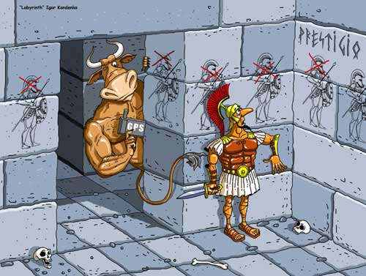
The next morning all the Athenians went into the Labyrinth. The others were afraid, but Prince Theseus tied the string to the door and started to search for the dreaded Minotaur. Finally he did find the beast and, after a long struggle, Theseus killed the Minotaur with his sword and followed the string back to the door. The other Athenians were very happy to see him and to hear that he had killed the Minotaur!

Princess Ariadne opened the door and let them out, and they all ran away to their ship and sailed away: Theseus, Ariadne, and all the other Athenians.

But when Theseus and Ariadne got to the island of Delos, halfway home from Crete, they stopped to rest. Ariadne fell asleep, and Theseus left her there on the island and sailed away to Athens without her. Different Greek stories give different reasons why he did this: maybe he just didn't like her very much, or maybe he thought the Athenians wouldn't like her because she was Cretan. Or maybe he was afraid King Minos would be angry.

When Theseus got as far as Sounion, he was close enough for the ship to be seen from Athens. But he had forgotten to change the sail from black to white! His father, King Aegeus, was looking out for Theseus' ship. When he saw the black sail he thought Theseus was dead, and he was so sad that he jumped off the cliff and killed himself.

Following the death of his father, Theseus was crowned as the new king and was respected for being a great leader and king.

Aim: To understand some of the features of narrative and their impact on the reader.

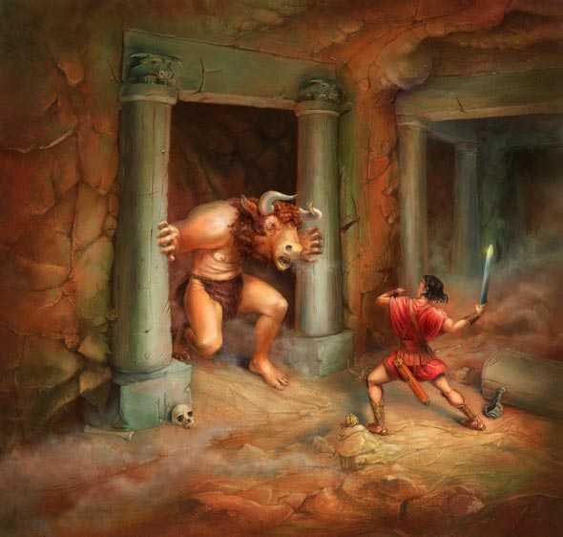
It is important that we understand how a text is written and the benefits of why it is written in a particular way.

Task 1: Read the story of ‘Theseus and the Minotaur’ on the next page and find a quote (a line from the text) that proves each of the following…
- That the story is written using third person narrative (‘he’, ‘she’ and ‘they’ etc.)
- That the narrator (the person telling the story) is omniscient which means they can see everything and even say what characters are thinking.
- That the story is written in past tense (the events happened in the past).

Task 2: Why do you think that most myths are told using third person narrative and in the past tense? Think about the events and actions that take place, the length of time between events, when the events were supposed to have taken place and any benefits for the reader.

Task 3: Symbolism is often used in myths. In the table below are some of the symbols used in ‘Theseus and the Minotaur’ and, on the right side, some suggestions about what the symbols could represent. Copy the table into your book and match the correct symbol with the correct suggestions.
Symbol | What this symbol suggests
The maze that Theseus has to escape | That evil is ugly but there is some evil in all men
The Minotaur having the head of a bull and the body of a man | Death.
The string | That a hero never has an easy path and must fight to reach the end.
The black sails on Theseus’ ship | Connection/hope.
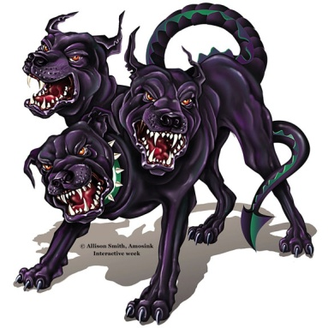
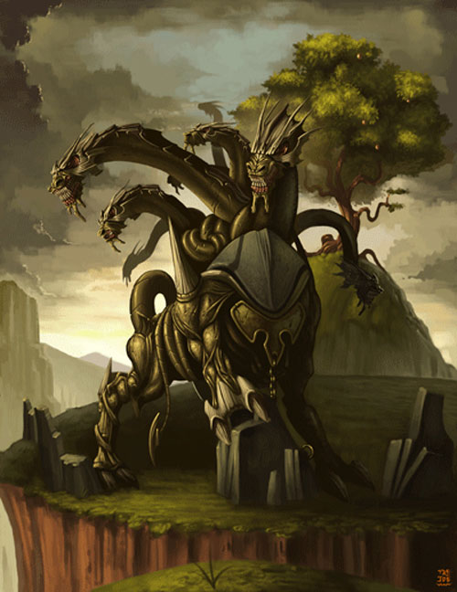
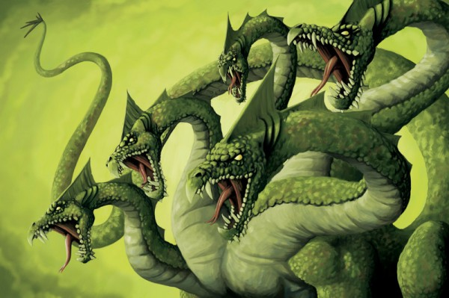

Task 4: Above are pictures of 3 mythical creatures – The Hydra, Ceberus and The Ladon Dragon.
- What similarities do you see between these creatures/pictures?
- Why do you think heroes are put against these types of monsters? Why are heroes always at a disadvantage?

Task 5: Using the pieces below you are going to cut out and make your own hero. You are going to equip your hero with weapons and clothing that will make him as heroic as possible. You are only allowed to spend a maximum of 500 ‘Hero Dollars’ on equipping your hero and each item you add can both take away or improve the hero’s quality. The hero is judged on 4 qualities:
- Attack: How physically strong and powerful your hero is.
- Defence: How well your hero can stand up against the attacks of others.
- Speed: How quick your hero is.
- Fame: How famous your hero is (famous heroes always have magical weapons and do not worry about defending themselves).

Instructions:
- Cut out your hero (your teacher may want you to stick him into your book)
- Decide what equipment you will give him and cut it out (if you are sticking the hero into your book you do not have to cut out the tabs on each piece of equipment – just stick them straight onto him). Remember you can only spend a maximum of 500 Hero Dollars.
- When you have equipped your hero, work out how high each of his qualities are (attack, defence, speed and fame).
- On your table, work out who has, statistically, the most powerful hero.
Tunic
Cost: 150
Attack: +5
Defence: +10
Speed: -0
Fame: +10
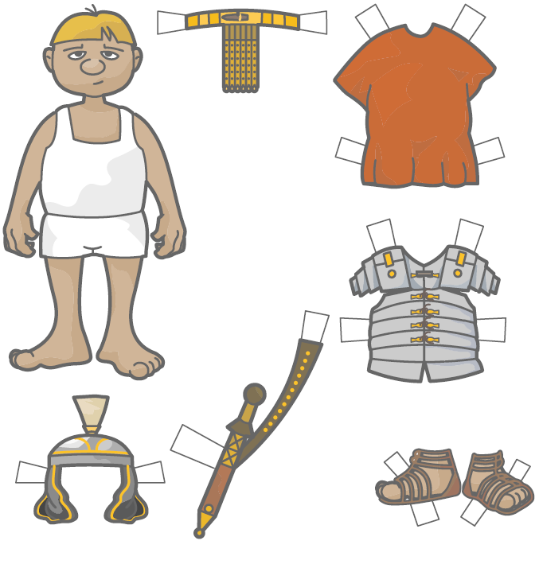
The Hero
Attack: 50
Defence: 50
Speed: 50
Fame: 50
Ajax Sword
Cost: 300
Attack: +30
Defence: +10
Speed: -0
Fame: +20
Helmet
Cost: 200
Attack: +10
Defence: +20
Speed: -5
Fame: -10
Sandals
Cost: 50
Attack: +5
Defence: +5
Speed: +20
Fame: -0
Armour
Cost: 300
Attack: +10
Defence: +30
Speed: -10
Fame: -10
The Golden Belt of Remus
Cost: 250
Attack: +5
Defence: +15
Speed: -5
Fame: +20

