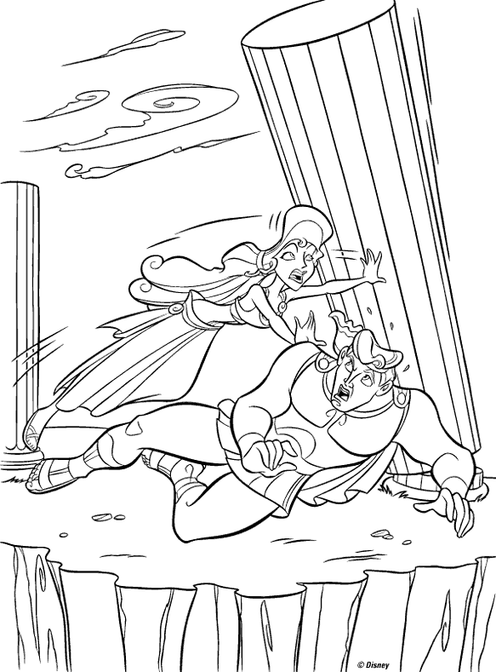
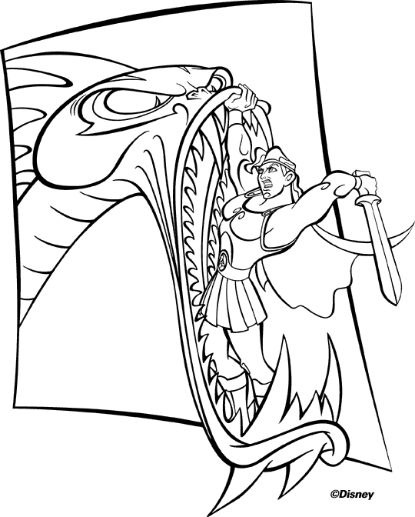
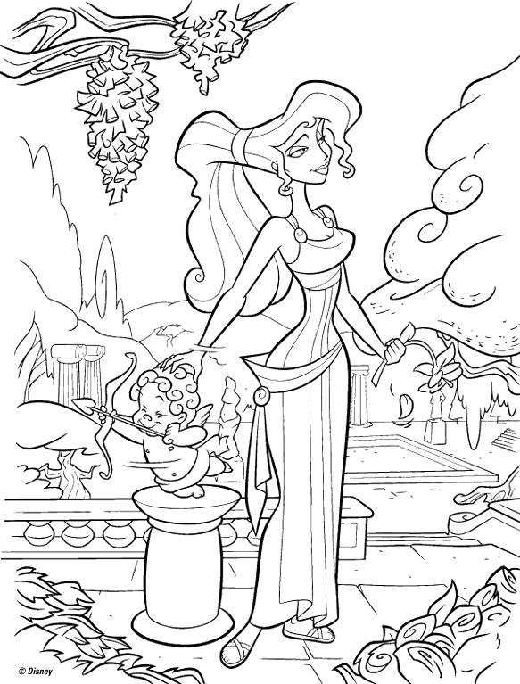
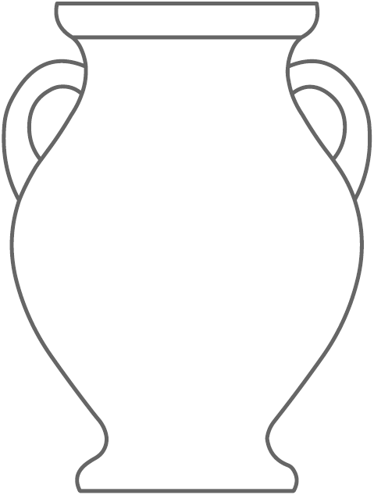
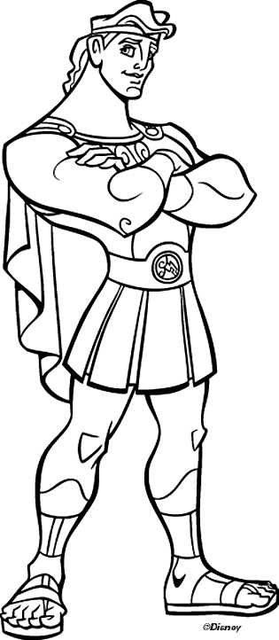
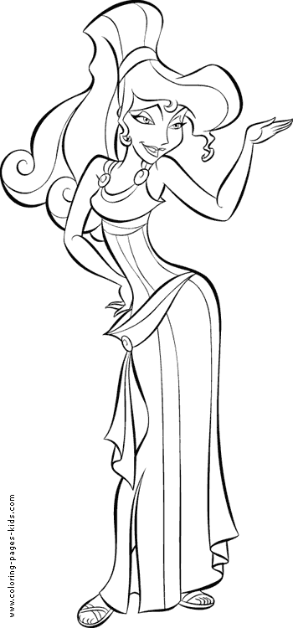

Aim: To consider where texts and stories come from.

The English we speak today is made up of many different ‘older’ languages. Over one thousand years ago the English language was not like it is today, it was spoken and written in a completely different way. However, there are many stories that still exist from thousands of years ago.
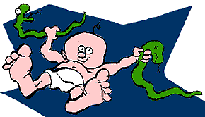
Task 1: On the right are two parts of information that tell us about the mythical Greek hero Hercules. Read the extracts and answer the following questions:
- Based on the extracts, why do you think the story and myth of Hercules still exists to this day? Think about the background, adventures, qualities and powers of Hercules.
Hercules was the Roman name for the greatest hero of Greek mythology -- Heracles. Like most authentic heroes, Hercules had a god as one of his parents, being the son of the king of the gods Zeus, and a mortal woman. Zeus's queen Hera was jealous of Hercules, and when he was still an infant she sent two snakes to kill him in his crib. Hercules was found prattling delighted baby talk, a strangled serpent in each hand.

- Copy a quote (a line from the extract) that you think would make the story of Hercules appeal to males. Once you have written a quote state what words would appeal to males and why you think they would like the story.

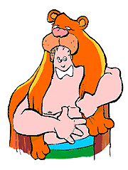
Despite many people being unable to read or write, the story and adventures of Hercules were known by everyone in ancient Greece.

Task 2: Look at the statement above in italics. Based on this information, which of the following statements do you think is the most correct and why (give reasons for your answer)?
- Most people in ancient Greece knew about the story of Hercules because they learnt about him in school.
- Most people in ancient Greece knew about the story of Hercules because they listened to someone describe his adventures.
As one of his first heroic tasks, Hercules was challenged to kill the Nemean lion. This was no easy feat, for the beast was more like a monster than an ordinary lion. Its skin could not be penetrated by spears or arrows. Hercules blocked off the entrances to the lion's cave, crawled into the close confines where it would have to fight face to face and throttled it to death with his bare hands. Ever afterwards he wore the lion's skin as a cloak and its gaping jaws as a helmet.

- Most people in ancient Greece knew about the story of Hercules because they saw pictures showing some of his adventures.
Task 3: The picture on the left is the painting of a jar that shows Hercules (in the middle) fighting. Write at least one paragraph describing what is happening as if you were writing a story about it.

Task 4: The ancient Greeks used to decorate plates and jars with pictures telling the stories of their favourite heroes’ stories (like comic books today). You are going to design a jar that tells your own Hercules story.
- On the following page is an outline of a Greek jar (your teacher may give you a separate page with this on). Carefully cut out the jar and stick it into your book.
- Around the picture of the jar are some pictures from the modern Disney Hercules cartoon. Think of a story that could be happening based on these pictures (obviously the jar can only show a small part of the story). Cut out whichever of the pictures you think would best tell your story and stick them onto your jar. You can draw on some extra pictures if you wish.
- Colour in your jar and pictures.

Task 5: Write some paragraphs telling the story (that you were telling on the jar from the last task) in detail.

One of the languages that has influenced English is Latin. This was a language that was used in the Roman Empire two thousand years ago.

Task 6: Below are some English phrases and their Latin translations. Copy the table into your book.
English Phrase | Latin Translation
Welcome | Salve
Long time no see | Quantum temporem!
What’s your name? | Quid est nomen tibi?
My name is… | Nomen mihi est...
Good Night | Bonam Noctem!
Good Luck | Bonam Fortunam!
Please write it down | Sodes, id scribes?
How much is this? | Quanti constat?
Where’s the toilet? | Ubi sunt latrinae?
I love you | Te amo

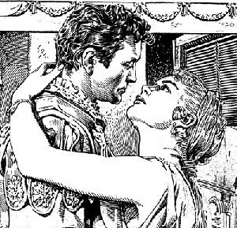
Task 7: When you look at the Latin translations above you make recognise that some words look or sound similar to modern English, French and Spanish. Highlight or copy which words you think mean the following:
- Good
- Is
- Write
- Name
- Night
- Luck
- Toilet

Extension: Imagine you are a character in an ancient Roman soap-opera. Write a diary entry explaining about an event that has happened in your life recently. You can write in English but try to include as many of the Latin phrases as possible.

