Yr10 Food and Nutrition GCSE Group
Easter break to May half term – https://www.bbc.co.uk/bitesize
Week 1 Task 1
Instructions on how to navigate the task on your computer
- BBC Bitesize
- Secondary
- England KS3
- Subject: Design Technology
- Food Technology
- How yogurt is made 4 minutes and 53 seconds
Task – Extended written task
- Make written steps on how the yogurt is made using the clip to help you
- WRITE A PARAGRAPH EXPLAINING HOW TO MAKE YOGURT
- What is meant by good bacteria and which ones are good? (CHALLENGE)
- What is lactic acid? (CHALLENGE)
* * * * * * * * * * * * * * * * * * * * * * * * * * * * * * * * * * * * * * * * * * * * * * * * * * * * * * * *
Week 1 – Task 2
Instructions on how to navigate the task on your computer
- BBC Bitesize
- Secondary
- England KS3
- Subject: Design Technology
- Food Technology
- How low fat mayonnaise is made 8 minutes and 31 seconds
Task – Research (extended written task)
Explain how mayonnaise is made in detail and explain what an emulsion is.
Explain how low fat mayonnaise is made and how this differs to full fat mayonnaise
Explain the key ingredients that make Light mayonnaise work.
* * * * * * * * * * * * * * * * * * * * * * * * * * * * * * * * * * * * * * * * * * * * * * * * * * * * * * * *
Week 1 – Task 3 (ONLY complete the cooking task if you have the ingredients and are being supervised)
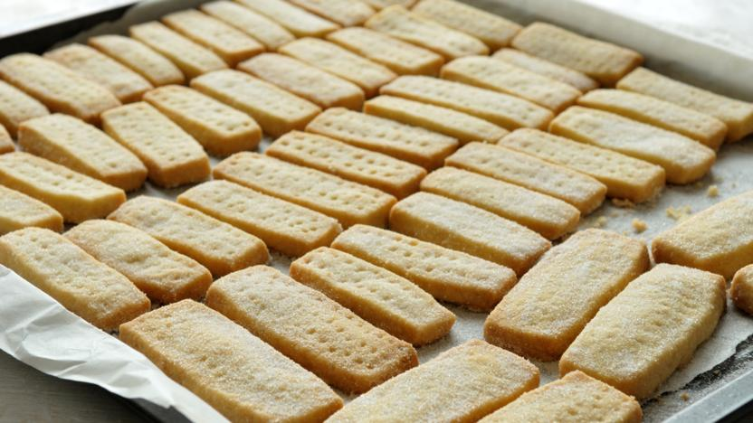
Shortbread Biscuits
Ingredients
125g/4oz butter
55g/2oz caster sugar, plus extra to finish
180g/6oz plain flour
Method
- Heat the oven to 190C/375F/Gas 5.
- Beat the butter and the sugar together until smooth.
- Stir in the flour to get a smooth paste. Turn on to a work surface and gently roll out until the paste is 1cm/½in thick.
- Cut into rounds or fingers and place onto a baking tray. Sprinkle with caster sugar and chill in the fridge for 20 minutes.
- Bake in the oven for 15-20 minutes, or until pale golden-brown. Set aside to cool on a wire rack.
///////////////////////////////////////////////////////////////////////////////////////////////
Week 2 – Task 1
Instructions on how to navigate the task on your computer
- BBC Bitesize
- Secondary
- England KS3
- Subject: Design Technology
- Food Technology
- How processed cheese is made 6 minutes and 21 seconds
Explain how cheese is made; break this task down into steps like a recipe
What is used to separate the milk into the two parts?
What are curds and whey?
Name 2 good bacteria’s (CHALLENGE)
Explain the difference between regular cheese and processed cheese
* * * * * * * * * * * * * * * * * * * * * * * * * * * * * * * * * * * * * * * * * * * * * * * * * * * * * * * *
Week 2 – Task 2
Instructions on how to navigate the task on your computer
• BBC Bitesize
• Secondary
• England KS3
• Subject: Biology
• Nitrogen, digestion and excretion
• What is a healthy diet? 1 minute and 16 seconds
Task – Written task
Explain what a healthy diet is and explain what is needed in that healthy diet. (150 words)
Scroll Down – have a go at the quiz, write the questions and your answers down on paper
Scroll down – What is digestion
Make notes on the 1 minute 57 second clip, bullet points would be fine. Scroll down and you will find some written text to help you with this.
Complete the digestion Quiz; write down the questions and your answers.
What is coeliac disease? Explain in detail.
* * * * * * * * * * * * * * * * * * * * * * * * * * * * * * * * * * * * * * * * * * * * * * * * * * * * * * * *
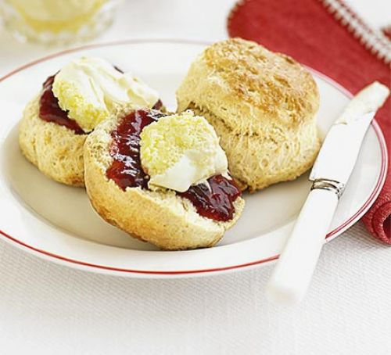
Week 2 – Task 3 (ONLY complete the cooking task if you have the ingredients and are being supervised)
Scones Makes 4
90g self-raising flour, plus more for dusting
Pinch salt
¼ tsp baking powder
20g butter, cut into cubes
1 tbsp caster sugar
45ml milk
squeeze lemon juice
beaten egg, to glaze
jam and clotted cream, to serve

Method
- Heat oven to 220C. Tip the flour into a large bowl with the salt and baking powder, then mix. Add the butter, then rub in with your fingers until the mix looks like fine crumbs. Stir in the sugar.
- Put the milk into a jug and heat in the microwave for about 30 secs until warm, but not hot. Add the vanilla and lemon juice, then set aside for a moment. Put a baking sheet in the oven.
- Make a well in the dry mix, then add the liquid and combine it quickly with a cutlery knife – it will seem pretty wet at first. Scatter some flour onto the work surface and tip the dough out. Dredge the dough and your hands with a little more flour, then fold the dough over 2-3 times until it’s a little smoother. Pat into a round tin about 4cm deep.
- Take a 5cm cutter (smooth-edged cutters tend to cut more cleanly, giving a better rise) and dip it into some flour. Plunge into the dough, then repeat until you have four scones. You may need to press what’s left of the dough back into a round to cut out another four.
- Brush the tops with beaten egg, then carefully place onto the hot baking tray.
- Bake for 10 mins until risen and golden on the top.
///////////////////////////////////////////////////////////////////////////////////////////////

Week 3 – Task 1
Instructions on how to navigate the task on your computer
- BBC Bitesize
- Secondary
- England KS3
- Subject: Design Technology
- Food Technology
- How pre-cooked rice is made safe to eat 4 minutes and 42 seconds
Task – Note taking (being able to source relevant information from the information provided)
Take notes on the clip, this is easier done as bullet points
Why is nitrogen gas used, why is this so important? (CHALLENGE)
What is the toxin in rice?
Explain what MAP is and how it is used in packaging food and keeping food safe.
Name 3 different types of food poisoning.
Explain what sterilisation is.

* * * * * * * * * * * * * * * * * * * * * * * * * * * * * * * * * * * * * * * * * * * * * * * * * * * * * * * *
Week 3 – Task 2
Instructions on how to navigate the task on your computer
• BBC Bitesize
• Secondary
• England KS3
• Subject: Biology
• Health and disease
- What is Malnutrition
Task – Extended written task
In your own words explain what malnutrition is using the clip and the text.
Explain the following within your text
- Anaemia
- Blindness
- Scurvy
- Acute and chronic malnutrition
- Health problems associated with obesity
- Explain how to tackle malnutrition

* * * * * * * * * * * * * * * * * * * * * * * * * * * * * * * * * * * * * * * * * * * * * * * * * * * * * * * *
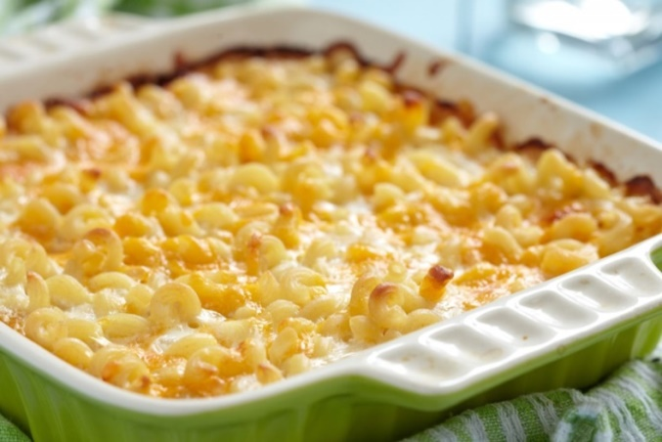
Week 3 – task 3 (ONLY complete the cooking task if you have the ingredients and are being supervised)
Macaroni Cheese
250g macaroni
1 tbsp butter
1 tbsp plain flour
450ml milk
cheddar cheese, grated
1 tsp black pepper
1 tsp mustard powder

Method
- Cook the macaroni according to the packet instructions and drain when cooked
- Heat the butter (or margarine) and when melted, add a generous tablespoon of plain flour and mix it in
- Add some black pepper and a little nutmeg or mustard powder - cook on a low heat, stirring all the time, for about 30-60 seconds
- Add the milk a little at a time and mix well with a whisk - you should end up using about 450ml of milk
- Bring to the boil, stirring all the time, to thicken the sauce, then add a big handful of grated cheddar cheese to make it a cheese sauce
- Add the drained pasta to the cheese sauce and stir well
- Serve straight away or put into an oven proof dish, grate some more cheese over and bake at 180'C/Gas mark 5 for 10 minutes
///////////////////////////////////////////////////////////////////////////////////////////////
Week 4 – Task 1
Instructions on how to navigate the task on your computer
- BBC Bitesize
- Secondary
- England KS3
- Subject: Design Technology
- Food Technology
- How milk is homogenised and pasteurised 6 minutes and 26 seconds
Task – EXTENDED WRITTEN TASK
Explain the term and the process of homogenisation, explain the before and after slides shown under the microscope (in detail)
Why is milk homogenised?
Explain what pasteurisation is, be clear about the temperatures and explain why, why does the milk stay fresher for longer?
* * * * * * * * * * * * * * * * * * * * * * * * * * * * * * * * * * * * * * * * * * * * * * * * * * * * * * * *
Week 4 – Task 2
Draw the chart below and fill it in
Benefits of buying locally sourced foods | Benefits of buying seasonal fruit and vegetables
Explain what is meant by the term ‘Carbon Footprint’

* * * * * * * * * * * * * * * * * * * * * * * * * * * * * * * * * * * * * * * * * * * * * * * * * * * * * * * *
Week 4 – Task 3 (ONLY complete the cooking task if you have the ingredients and are being supervised)
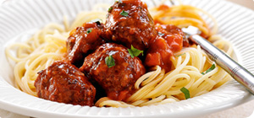
Beef meatballs in tomato sauce
200g Minced Beef
30g dry breadcrumbs
¼ onion, grated
1tbsp grated parmesan
½ garlic clove
½ tbsp. chopped parsley
½ egg
Salt and pepper
Plain flour for dredging
Vegetable oil for frying

Method
- Combine the beef, b _ _ _ _ _ _ _ _ _ s, onions, garlic, herbs, eggs, salt and pepper in a m_ _ _ _ g bowl. Shape into 5 meatballs, toss in f _ _ _ r.
- Heat oil in a frying pan, cook the m _ _ _ _ _ _ _ s until cooked through and b _ _ _ _ _ d all over. Add the passata and s _ _ _ _r for 10 m _ _ _ _ _ s.
- S _ _ _ e with p _ _ _ a.

///////////////////////////////////////////////////////////////////////////
Week 5 – Task 1
Instructions on how to navigate the task on your computer
- BBC Bitesize
- Secondary
- England KS3
- Subject: Design Technology
- Food Technology
- Why keep broccoli chilled 3 minutes and 27 seconds
Task – case study (use of information to explain the process of chilling on food)
Pick 1 other product that you know needs to be chilled and explain some of the scientific reasons for chilling, state the temperatures for chilling and the benefits of this process
Draw and complete the chart below with as much detail as you can think of
Benefits of refrigerating foods | Some bad points about refrigeration
Make a list of other methods of preserving foods and state how they are preserved
Method of preserving | How they are preserved

* * * * * * * * * * * * * * * * * * * * * * * * * * * * * * * * * * * * * * * * * * * * * * * * * * * * * * * *
Week 5 – Task 2
- BBC Bitesize
- Secondary
- England KS3
- Subject: Design Technology
- Food Technology
- Why keep broccoli chilled 3 minutes and 27 seconds
- How sugar is refined 3 minutes and 33 seconds
Task - Answer the following questions (fact finding and data extraction from a clip)
What is sugar made from?
What else is sugar made from? (CHALLNGE)
Why is sugar white?

Explain the key words
Extraction
Filtered
Stew
Impurities
Evaporation
Centrifuge
* * * * * * * * * * * * * * * * * * * * * * * * * * * * * * * * * * * * * * * * * * * * * * * * * * * * * * * *
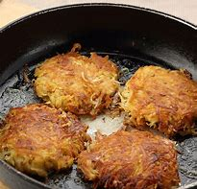
Week 5 – Task 3 (ONLY complete the cooking task if you have the ingredients and are being supervised)
Potato and Cheese Rostis
2 red or waxy potatoes
50g strong cheddar
1 red onion
3 tablespoons vegetable oil
parsley
Tomato ketchup for dipping
Salt and pepper
Optionall extras
1 tbps sweetcorn
½ chilli
Method
1. Boil the potatoes for 20 minutes
2. Finely chop the onion
3. Grate the potatoes into a bowl
4. Grate the cheese and add to the potatoes
5. Season with salt and pepper
6. Make four balls of equal size and shape them into patties
7. Brush each rosti with oil and dry fry until golden brown
///////////////////////////////////////////////////////////////////////////////////////////////
Week 6 – Task 1
Instructions on how to navigate the task on your computer
- BBC Bitesize
- Secondary
- England KS3
- Subject: Chemistry
- Chemical reactions and tests
- How to turn starch into glucose 1 minute and 8 seconds
Task – Have a go at the CREAM CRACKER task
- Explain the terms
- Starch useing examples
- Amylase
- Explain how glucose is made

* * * * * * * * * * * * * * * * * * * * * * * * * * * * * * * * * * * * * * * * * * * * * * * * * * * * * * * *
Week 6 – Task 2
Instructions on how to navigate the task on your computer
• BBC Bitesize
• Secondary
• England KS3
• Subject: Chemistry
• Chemical reactions and tests
- How to make bread
Task – Written and research task
- Explain How to make bread (title) using the 2 minute clip. Write this like the method of a recipe in numbered stages.
- What is the purpose of the yeast ?
- What is the purpose of the sugar and the flour?
- Which gas is made?
- Explain the term proving (CHALLENGE)
- What chemical reaction happens in the oven (CHALLENGE)

* * * * * * * * * * * * * * * * * * * * * * * * * * * * * * * * * * * * * * * * * * * * * * * * * * * * * * * *

Week 6 – Task 3 (ONLY complete the cooking task if you have the ingredients and are being supervised)
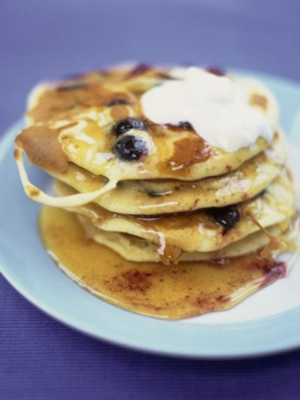
American style pancakes

Ingredients
3 large free-range eggs
115 g plain flour
1 heaped teaspoon baking powder
140 ml milk
Method
- First separate the eggs, putting the whites into one bowl and the yolks into another.
- Add the flour, baking powder and milk to the yolks and mix to a smooth thick batter.
- Whisk the whites with 1 pinch of sea salt until they form stiff peaks, then fold into the batter – it is now ready to use.
- Heat a non-stick pan over a medium heat, pour some of the batter into the pan and cook for a couple of minutes, or until it starts to look golden and firm.
- At this point sprinkle your chosen flavouring (see below) onto the uncooked side before loosening with a spatula and flipping the pancake over. Continue frying until both sides are golden.

/ KS3 BIOLOGY – NUTRITION, DIGESTION AND EXCRETION / HEALTH AND DISEASE

