NAME:
Just like us humans, products will survive for different amount of times; some will be around for decades, or even centuries, whilst others will last for just a few weeks.
The Life of a Product
Task 1
Below you will see five different product lifecycle diagrams that depict the life of a product. Opposite each one is a description – but they’ve been mixed up. Can you match the correct description to each diagram?
Match the Product Lifecycle Diagram Shown to the Correct Description
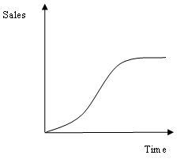 |  | A new product which is described as a “fad” – it is popular for a short time.
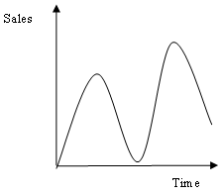 |  | A product that has established itself, and maintained sales over a long period of time.
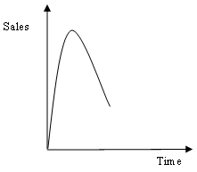  Sales  Time |  | A product that could be described as a “slow-burner” as it takes a while for sales to increase significantly
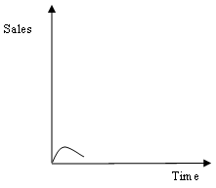  Sales  Time  Sales  Time |  | A seasonal product
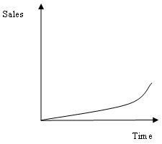 |  | A product that flopped, and failed to be popular.

Task 2
Using the same five different product lifecycle diagrams that were used in Task 1, now try to think of an example product that has or had the life-cycle described. Then complete the table by explaining what extension strategies a business might want to use in each of these scenarios.

Product Lifecycle Diagram |  | Example Product |  | Possible Extension Strategy
Sales
Time
Sales
Time
Sales
Time

