Paper 2: Relationships and families
Topics checklist
- Can I identify how laws and general attitudes have changed towards homosexuality in Britain over the last century?
- Can I explain why some Christians are against homosexual relationships and only support heterosexuality?
- Can I explain why some Christians support homosexual relationships?
- Can I explain why some Christians agree with sex before marriage and some do not?
- Can I explain why all Christians disagree with adultery?
- Can I give examples of artificial and natural methods of contraception and why it is used?
- Can I explain why Catholics do not agree with using artificial contraception and why other Christians agree?
- Can I describe the different types of marriage in the UK today? (same-sex, civil partnership etc.)
- Can I explain Christian teachings about the nature of marriage? (heterosexual/homosexual)
- Can I explain Christian teachings about the purpose of marriage?
- Can I explain why some Christians allow cohabitation and some do not?
- Can I give different reasons for and against divorce?
- Can I explain why Catholics disagree with divorce and why the Church of England allows it?
- Can I describe the different types of families in Great Britain?
- Can I explain Christian teachings about the nature of families?
- Can I explain what Christians are taught about the role of parents and children?
- Can I explain the three main purposes of families?
- Can I identify how attitudes have changed about the roles of men and women I Britain over the last century?
- Can I give examples of gender prejudice and discrimination? (for both genders)
- Can I explain different Christian views about the roles of men and women?
Human sexuality – heterosexuality and homosexuality
Attitudes towards homosexuality have changed considerably over the past century. This is reflected in the various changes in law. Try to know some of the key changes in law.

- 1885 – homosexual acts are made illegal
- 1967 – homosexual acts are made legal for people over 21, but not if you are in the army
- 1994 – age of consent (to sex) is lowered to 18
- 2000 – homosexuals are allowed to join the army
- 2001 – age of consent is lowered to 16, to match the age of consent for heterosexual people
- 2004 – civil partnerships are introduced
- 2013 – same-sex marriage is made legal
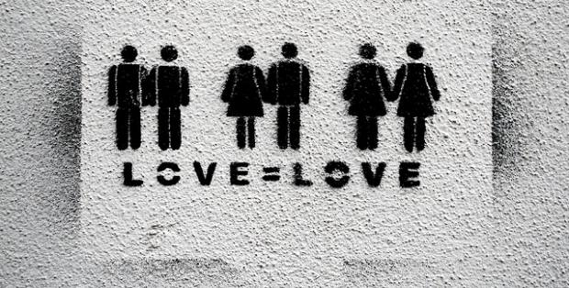

Different Christian views on homosexuality
Sex before marriage (pre-marital sex)

Most Christians are against having sex before marriage. This is because:
Useful quote from the Catechism of the Catholic Church:
‘The sexual act must take place exclusively within marriage. Outside of marriage it always constitutes a grave sin.’
- Sex should only take place within marriage as it is a gift from God.
- They believe that there are two purposes for sex:
  - To unite a married couple
  - For procreation (making babies)
- The Bible teaches against sex outside of marriage. For example, St Paul says:

‘Free from sexual immorality … whoever sins sexually, sins against their own body. Do you not know that your bodies are temples of the Holy Spirit?’ (1 Corinthians 6:18-19)

HOWEVER, some Christians accept pre-marital sex if both people committed and in love. They would encourage the couple to marry in the future.

Sex outside of marriage (adultery)

All Christians disagree with adultery. This is because:
- It breaks the wedding vows, which were promises made before God
- It breaks up the family, which is very important to Christians
- It goes against one of the 10 commandments ‘Thou shall not commit adultery’ (Exodus 20:14)
- Jesus taught that lust is wrong because this can lead to adultery ‘anyone who looks at a woman lustfully has already committed adultery with her in his heart’ (Matthew 5:27-28)

Contraception
Natural methods of contraception
Coitus interruptus = withdrawal method
Calendar rhythm method = when a couple time when they have sex to the least fertile times of a woman’s cycle.

These methods are not as effective as artificial methods and do not protect you against STDs.
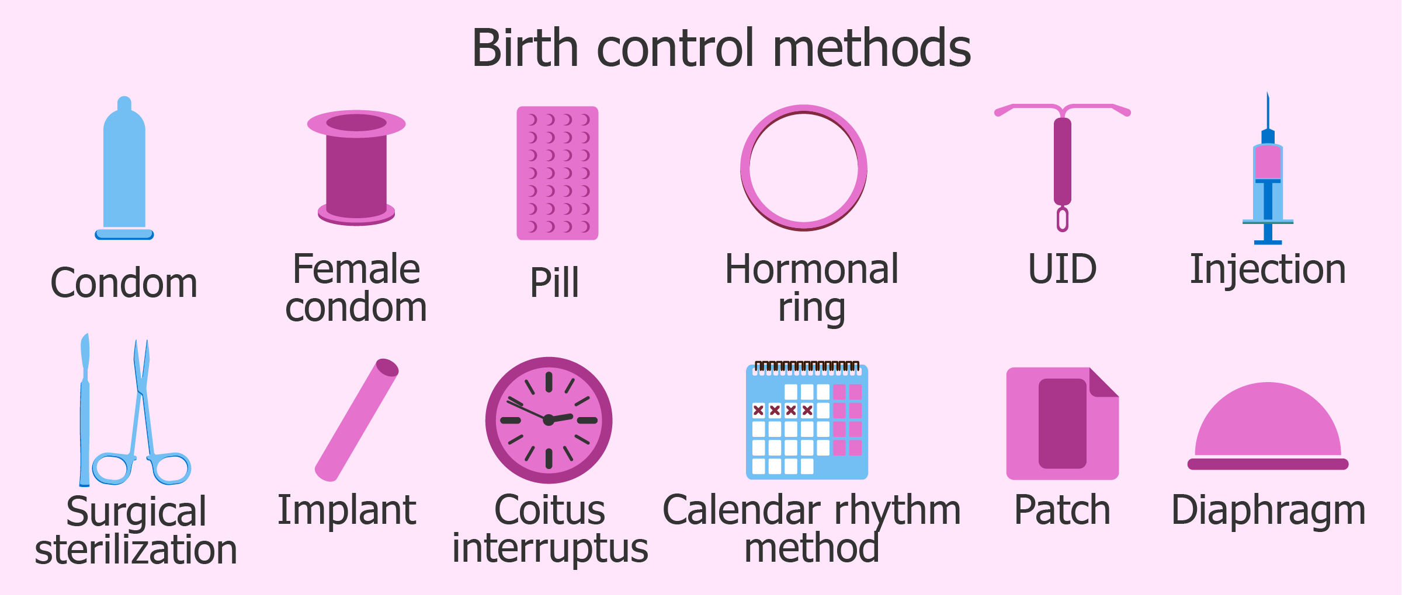

Two different Christian views about the use of artificial contraception…

Marriage

How has the nature of marriage changed?

- In 2004, civil partnerships were brought into law allowing same-sex couples to have the same legal rights as married couples.
- In 2014, same-sex marriages were legalised.

Many, Christians disagreed with same-sex marriage as they believe that the nature of marriage should only be between a man and a woman.

What is the purpose of marriage for Christians?
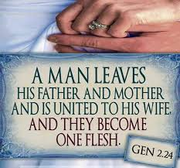
- It is one of God’s gifts at creation in the book of Genesis. Adam and Eve were joined together and became ‘one flesh’.
- It provides a stable relationship for the procreation of children.
- For Catholics, it is a sacrament.
- It is a spiritual bond between the couple and God.
- It provides a stable basis for a sexual relationship.

Divorce

Two different Christian views about divorce

In the Gospel of Mark, Jesus seems to teach against divorce. He says:
‘Anyone who divorces his wide and marries another woman commits adultery against her’ (Mark 10:11)

In the Gospel of Matthew, Jesus seems to allow divorce in cases of adultery. He says:
‘If a man divorces his wife for any cause other than unchastity (unfaithfulness), he involves her in adultery’ (Matthew 5:32)

Families

What are the different types of families in the UK?

Nuclear family
Christian teachings on the nature of families

- Families are very important to Christians
- Ideal family is of a married man and woman and their children. They believe that this was created at the beginning of time with Adam and Eve.
- Some more traditional Christians disagree with same-sex parents because they feel it is better for children to grow up with a mother and father. They also believe God intended for it to be a man and woman.
- Some other Christians believe it is more important for a child to grow up in a secure and loving home, regardless of the gender of their parents.
A couple and their children
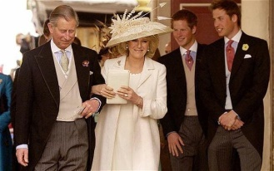 | Stepfamily  A family that is formed on the remarriage of a divorced or widowed person and that include a child or children.
Extended family

A family that extends beyond just parents and their children by including grandparents and other relatives.
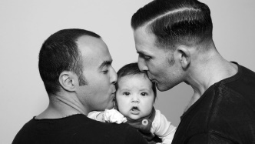 | Same-sex parents  People of the same sex who are raising children together.

The purpose of families

How should family members treat one another?

- The love in a family should reflect the love that God/Jesus has for his people: ‘Husbands, love your wives, just as Christ loved the Church and gave himself up for her’. Ephesians 5:25
- Children should respect their parents: ‘Honour your father and your mother’ Exodus 20:12
- Children should look after their parents when they’re elderly: ‘Listen to your father who gave you life, and do not despise your mother when she is old’ Proverbs 23:22
- Parents should not provoke or anger their children: ‘Fathers, do not exasperate your children; instead, bring them up in the training and instruction of the Lord.’ Ephesians 6:4

Gender Equality

Gender equality - men and women have the same rights and responsibilities as each other.

Gender prejudice - unfairly judging people because of their gender. This is usually because of gender stereotyping. E.g. girls like pink, men can’t be nurses

Gender discrimination – this is when you treat someone differently because of their gender. E.g. not giving someone a job
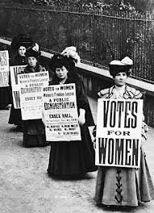
Views about the roles of men and women have changed over the past century. In the past, women were not able to vote, to divorce their husbands and were viewed mainly as housewives. These changes have occurred for a number of reasons, such as:
- During the world war one, two million women carried out traditionally male jobs
- Women were given the vote as a result of the Suffragette movement. In 1918, women over the age of 30 are given the right. This was lowered to 21, in line with men, in 1928.
- Sex Discrimination Act 1975 – made gender discrimination illegal in the UK
- Human Rights Act 1998 – made it illegal to discriminate someone because of their gender

However, gender discrimination still occurs. For example, on average women are paid less than men. Men tend to hold higher paid jobs.

What are Christian beliefs about gender equality?

Key words: Do you know these?
Human sexuality | How people express themselves as sexual beings
Heterosexual | When you are attracted to people of the opposite sex
Homosexual | When you are attracted to people of the same sex
Sex before marriage | Sex between two unmarried people
Adultery | When you have sex with someone who is not your marriage partner
Contraception | The methods used to prevent a pregnancy from taking place
Family planning | Controlling how many children couples have and when they have them
Marriage | A legal union between a man and a woman (or in some countries, two people of the same sex) as partners in a relationship
Civil partnership | A legal union of same-sex couples
Cohabitation | A couple living together and having a sexual relationship without being married to one another
Divorce | Legal ending of marriage
Remarriage | When someone marries again whilst their former spouse is still alive
Annulment | A Catholic Church ruling that a marriage was never valid
Nuclear family | A family that is made up of a mum, dad plus a child or children
Stepfamily | A family that is formed on the remarriage of a divorced or widowed person and that includes a child or children
Extended family | A family that extends beyond just parents and their children by including grandparents and their relatives as well
Polygamy | The practice or custom of having more than one wife at the same time
Bigamy | The offence of marrying someone while already married to another person
Procreation | Creating babies; making new life
Chastity | Keeping yourself sexually pure e.g. not having sex before marriage

Sample questions: give them a try!

One mark questions
- Which word best describes a sexual relationship between a man and woman?
- Homosexuality
- Heterosexuality
- Polygamy
- Marriage
- What is meant by chastity?
- The offence of marrying someone else when you are already married
- Keeping yourself sexually pure
- Creating babies; making new life
- The methods used to prevent a pregnancy from occuring
Two mark questions
- Give two examples of artificial contraception.
- Give two religious beliefs about divorce
- Give two types of families
Four mark questions (PEPE) – contrasting or similar beliefs in Themes paper. They will never specify Christianity, but you need to answer using Christianity.
- Explain two contrasting religious beliefs about sex before marriage. In your answer, you must refer to one or more religious traditions. (4)
- Explain two similar religious beliefs about contraception. In your answer, you must refer to one or more religious traditions. (4)
- Explain two contrasting religious beliefs about divorce. In your answer, you must refer to one or more religious traditions. (4)
Five mark questions (PEPER) – for the Themes paper, these are always explain two religious beliefs about X. They will never specify Christianity, but you need to answer using Christianity.
- Explain two religious beliefs about homosexuality. Refer to scripture or sacred writings in your answer. (5)
- Explain two religious beliefs about the nature of family. Refer to scripture or sacred writings in your answer. (5)
- Explain two religious beliefs about same-sex marriage. Refer to scripture or sacred writings in your answer. (5)
Twelve mark questions (DREARER+C or PEHE X3 + C)
‘Men and women do not have equal rights’. Discuss
‘No-one should ever support divorce’. Discuss
‘Nuclear families are the best type of family for the bringing up of children’. Discuss

