Surface Area of Cubes and Cuboids GREEN

Add together the areas of all the faces to find the surface areas of these cuboids (all the edges are measured in cm)

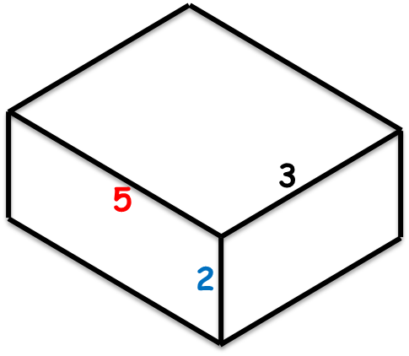
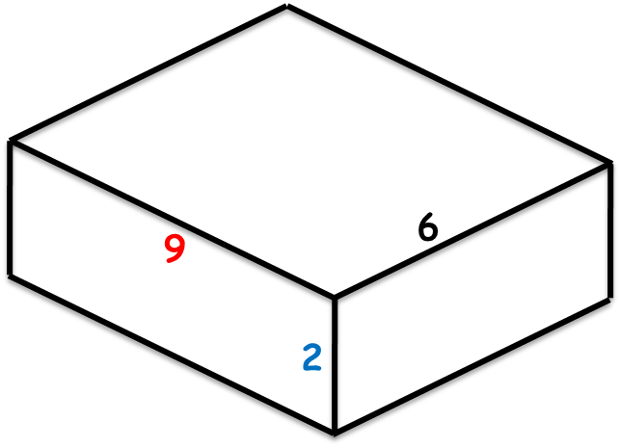
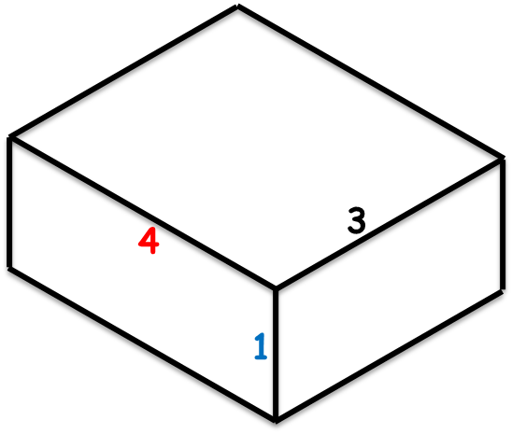

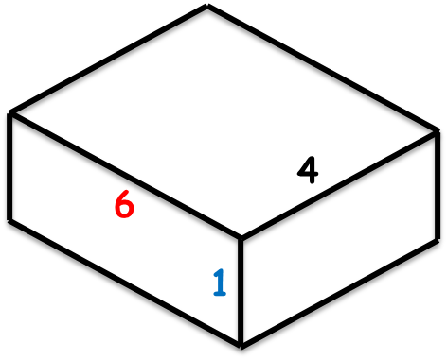

Surface Area of Cubes and Cuboids AMBER

Add together the areas of all the faces to find the surface areas of these cuboids (all the edges are measured in cm)

Front =
Back =
Left =
Right =
Top =
Bottom =
Surface Area =
Front =
Back =
Left =
Right =
Top =
Bottom =
Surface Area =

Front =
Back =
Left =
Right =
Top =
Bottom =
Surface Area =
Front =
Back =
Left =
Right =
Top =
Bottom =
Surface Area =

Surface Area of Cubes and Cuboids RED

Add together the areas of all the faces to find the surface areas of these cuboids (all the edges are measured in cm)

Front = 2 x 9 =
Back =
Left = 2 x 6 =
Right =
Top = 9 x 6 =
Bottom =
Surface Area (total) =
Front = 1 x 4 =
Back = 1 x 4 =
Left = 1 x 3 =
Right = 1 x 3 =
Top = 3 x 4 =
Bottom = 3 x 4 =
Surface Area (total) =

Front =
Back =
Left =
Right =
Top =
Bottom =
Surface Area (total) =
Front =
Back =
Left =
Right =
Top =
Bottom =
Surface Area (total) =

