Why set up a business?
The link below will take you to some theory that outlines many of the reasons why new business are set up
https://www.bbc.co.uk/bitesize/guides/zc3gkqt/revision/1
Instructions
- Read through the information of all 4 pages
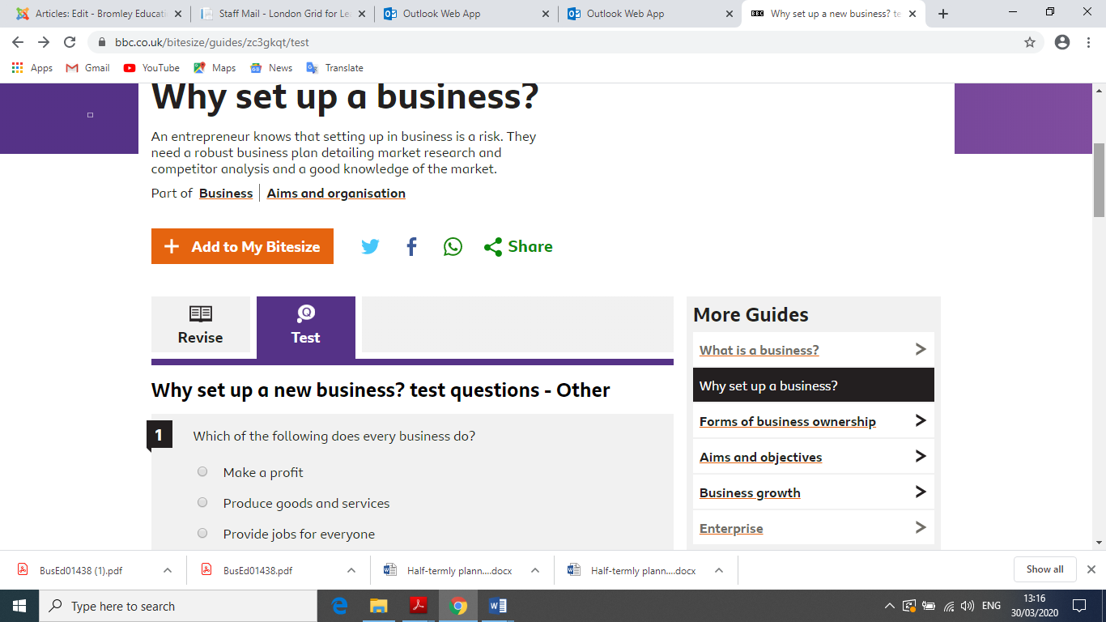
- On the last page there is an online test that you can complete on why new businesses are set up

