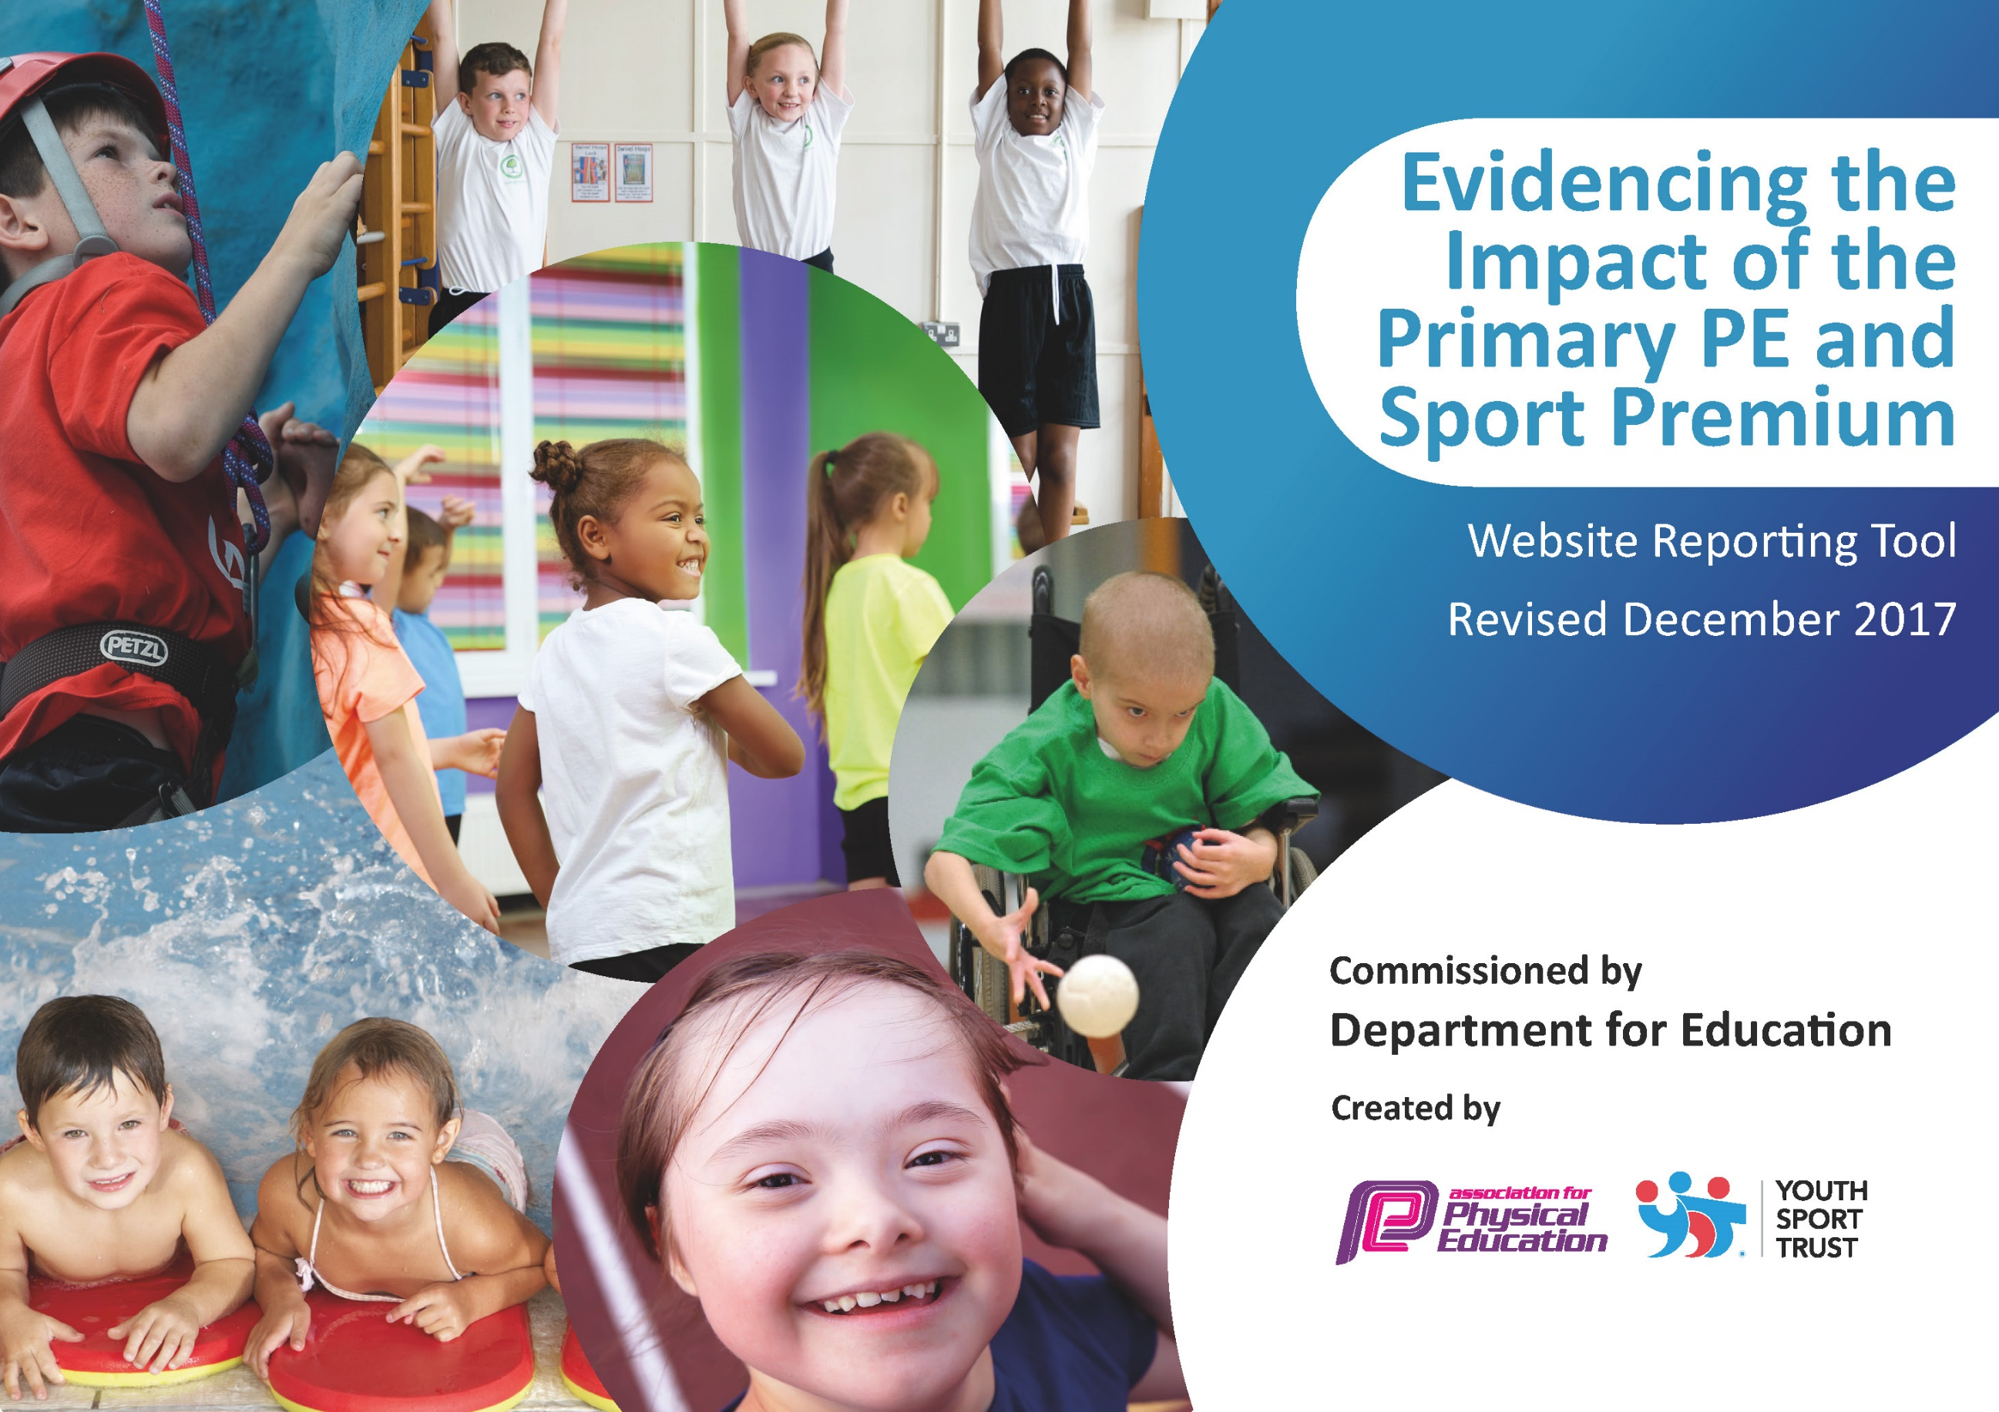

Schools must use the funding to make additional and sustainable improvements to the quality of PE and sport they offer. This means that you should use the Primary PE and Sport Premium to:

- develop or add to the PE and sport activities that your school already offers
- build capacity and capability within the school to ensure that improvements made now will benefit pupils joining the school in future years

Please visit gov.uk for the revised DfE guidance including the 5 key indicators across which schools should demonstrate an improvement. This document will help you to review your provision and to report your spend. DfE encourages schools to use this template as an effective way of meeting the reporting requirements of the Primary PE and Sport Premium.

We recommend you start by reflecting on the impact of current provision and reviewing the previous spend.
Under the Ofsted Schools Inspection Framework, inspectors will assess how effectively leaders use
the Primary PE and Sport Premium and measure its impact on outcomes for pupils, and how effectively governors hold them to account
for this.

Schools are required to publish details of how they spend this funding as well as on the impact it has on pupils’ PE
and sport participation and attainment.
We recommend regularly updating the table and
publishing it on your website as evidence
of your ongoing review into how you are using the money
to secure maximum, sustainable impact. To see an example of how to complete the table please click HERE.

Support for review and reflection - considering the 5 key indicators from DfE, what development needs are a priority for your setting and your students now and why? Use the space below to reflect on previous spend, identify current need and priorities for the future.

Key achievements to date: | Areas for further improvement and baseline evidence of need:
- Took part in two Football Festivals (no other evets were completed due to Covid 19).  - Additional resources purchased for break time activities. | - Look for alternative sporting opportunities outside in the wider community  - Identify non-swimmers earlier on in their school life and provide opportunities for regular swimming lessons  - Increase competitive fixtures and attend more sporting competitions against mainstream provisions  - to support lunchtime activities  - Extend competitive sport fixtures to more age groups and across linked schools  - Consider how we might introduce additional whole school active activities within the constraints of the school setting and available time  - Encourage healthier choices for personal health

Meeting national curriculum requirements for swimming and water safety | Please complete all of the below*:
What percentage of your current Year 6 cohort swim competently, confidently and proficiently over a distance of at least 25 metres? | 20% (2 pupils)
What percentage of your current Year 6 cohort use a range of strokes effectively [for example, front crawl, backstroke and breaststroke]? | 20% (2 pupils)
What percentage of your current Year 6 cohort perform safe self-rescue in different water-based situations? | 10% (1 pupil)
Schools can choose to use the Primary PE and Sport Premium to provide additional provision for swimming but this must be for activity over and above the national curriculum requirements. Have you used it in this way? | No
*Schools may wish to provide this information in April, just before the publication deadline.

Action Plan and Budget Tracking
Capture your intended annual spend against the 5 key indicators. Clarify the success criteria and evidence of impact that you intend to measure to evaluate for students today and for the future.

Academic Year: 2019/20 | Total fund allocated: £11,000 | Date Updated: July 2020
Key indicator 1: The engagement of all pupils in regular physical activity – |  |  |  | Percentage of total allocation:
 |  |  |  | 47.27%
School focus with clarity on intended impact on pupils: | Actions to achieve: | Funding allocated: | Evidence and impact: | Sustainability and suggested next steps:
For pupils to have an increased  understanding of the benefits a  healthy lifestyle, including regular  exercise can bring.  Emotional support to build self-esteem and confidence to have a go with sport in school. | 1, To encourage all children to  Participate in regular active play, PE & sport  2. Provide specialist teaching in PE and sport  3. Increase the range of sports offered  4. Increase engagement of KS1 children in active play and sports  School counsellor to run sessions with individual children, pairs and small groups to raise self-esteem and confidence to play sporting games at playtimes with others and raise confidence in having a go in PE sessions throughout the day. | £5200  Due to Covid 19 lockdown  £1700 will carry over to 2020/21 | Impact:  Increased participation from all  Improved outcome in PE and  across the curriculum  Work towards attaining the gold School Games Mark  Evidence:  Attainment levels in PE,  School games mark  Increased confidence in individual pupils. Increase of participation in PE lessons and school competitions | 90% of pupils will make expected progress (3 points) from their starting points.  Introduce Forest school and OPAL to expand opportunities for children to take part in regular physical activities.  Pupils achieve identified SEMH targets and show increased levels of independence, resilience, and a positive attitude to all areas of learning.
Key indicator 2: The profile of PE and sport being raised across the school as a tool for whole school improvement |  |  |  | Percentage of total allocation:
 |  |  |  | 6.36%
School focus with clarity on intended impact on pupils: | Actions to achieve: | Funding allocated: | Evidence and impact: | Sustainability and suggested next steps:
Ensure all children are aware of the importance of a healthy lifestyle, including diet and regular exercise.  Children are aware of sporting activities and achievements across the school.  Use | Use National healthy eating week resources in lessons and support from our healthy school dinner provider. Healthy eating covered in science-based learning and Learning & Life skills unit ‘It’s up to me’ across the school including opportunities for children to make healthy food options for parties and lunch bags.  Sports achievements integrated with Vision and Values assemblies weekly. Outside school sporting achievements celebrated in whole school vision and values assemblies weekly. | £400 for resources  £300  Due to Covid 19 lockdown  £100 will carry over to 2020/21 | Assemblies and healthy lunches promote healthy lifestyle. Children can identify healthy aspects when asked. Connected curriculum evaluations by staff & children  Pupil questionnaire of views about PE.  Greater visibility and celebration of our sporting achievements and children’s individual achievements. | Continue with weekly and half termly achievement assemblies and introduce sports assemblies  Sports display board.  Sports ports page in the College Magazine/ items in Trust newsletter  and on the BTA website.

Key indicator 3: Increased confidence, knowledge and skills of all staff in teaching PE and sport |  |  |  |  | Percentage of total allocation:
 |  |  |  |  | 14.54%
School focus with clarity on intended  impact on pupils: | Actions to achieve: |  | Funding  allocated: | Evidence and impact: | Sustainability and suggested  next steps:
Ensure key staff are confident in teaching and delivering high quality PE lessons.  To create a legacy for teaching PE  by ensuring schemes of work, systems for assessment and high quality resources are in place and constantly reviewed and improved on. | 1. Carry out skills audits and provide CPD to fill gaps  2. Employ specialist  teachers/coaches to  support/team teach with all members of staff  3. Provide advice and  support, as well as other resources for best practice in PE & sport |  | £1600  Due to Covid 19 lockdown  £550 will carry over to 2020/21 | Staff survey to be completed and analysed.  Observe range of PE lessons throughout the school | Key staff to utilise  knowledge, skills and  understanding to deliver  with increased confidence and ability.  Review results to determine additional CPD required.  Lesson observations  Audit of PE/Games equipment
Key indicator 4: Broader experience of a range of sports and activities offered to all pupils |  |  |  |  | Percentage of total allocation:
 |  |  |  |  | 13.63%
School focus with clarity on intended  impact on pupils: | Actions to achieve: |  | Funding  allocated: | Evidence and impact: | Sustainability and suggested  next steps:
Pupils have access to a wide, rich set of experiences, with the opportunity to develop, nurture and stretch talents or interests. | Climbing  Orienteering |  | £500  Training and equipment. £1000  Due to Covid 19 lockdown this activity did not run  £1000 will carry over to 2020/21 | Climbing, both indoors and out, gives pupils a community, builds their physical strength, and has numerous benefits to their stress levels and personal mental health.  Orienteering increases fitness levels: Most orienteering terrain is quite hilly and rugged, providing the perfect environment for athletes and nonathletes alike to develop strong hearts, legs, and lungs.  Increases cardiovascular capacity: Orienteering requires walking, jogging, and hiking, whose health benefits, enjoying time with nature: There is nothing more calming and centering than being in nature. Outdoors is good for vitamin D levels in the body and getting fresh air! Increases self-esteem: It takes courage, endurance, and mental fortitude to forge ahead by oneself through unknown areas, particularly in unfamiliar terrain and forests.  Enhanced pupil enjoyment and improved behaviour enabling increased concentration levels towards afternoon sessions – building of pupil resilience, independence, self-esteem and confidence to impact on other areas of curriculum, with improved outcomes and progress. | Get staff member to train as a climbing instructor.  Make link with local secondary school who have a climbing wall.  Set up own courses around school and local woods.
Key indicator 5: Increased participation in competitive sport |  |  |  |  | Percentage of total allocation:
 |  |  |  |  | 18.18%
School focus with clarity on intended  impact on pupils: | Actions to achieve: |  | Funding  allocated: | Evidence and impact: | Sustainability and suggested  next steps:
Raised pupil participation levels within sport-specific inter competitions  Pupils able to participate in, and have a broader range of physical activity experiences | Subscription to Borough SGO inter competition package  Subscription to South London Special league | £250  £250  + Supply day release  to address supervision of school teams at borough SGO and South London Special league led daytime inter competition events  £1500  Due to Covid 19 lockdown  £500 will carry over to 2020/21 |  | Increased number of children participating in intra & inter school sports competitions – 95% of all children to participate in at least one event. | Increased range of competitions/ intra & inter school sports competitions (at least three different sports/ areas).  Active play

